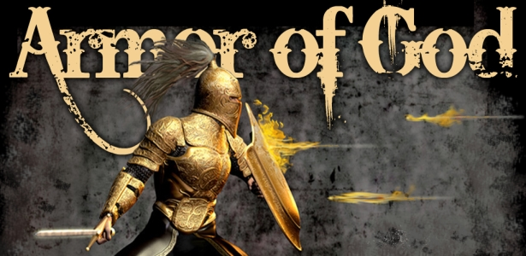

First Christian Church Sunday School Lesson
The Full Armor of God
Opening Prayer
God,
Thank you for loving us. You are with us and help us solve our problems. There is nothing that surprises You. There is nothing You can’t handle. You have given us Your Son so we can be Your children. You forgive us from our sins and give us the Holy Spirit to guide us. The Word of God tells us to use the “Armor of God” to protect us from sin. Thank you Father for helping us stay strong and close to You.
In Jesus Name we pray,
Amen

Praise and Worship
This is a fun song to help you remember all the Armor God has given us.
The Armor of God Fits Good on Me - Preschool Worship Song
By KidSpring Children’s Ministry
https://youtu.be/fMFGGHCd6Vs

This song is a marching chant with great graphics.
CMV: Put on the Armor of God
By INC Media News
https://youtu.be/X15rT0KMvSs
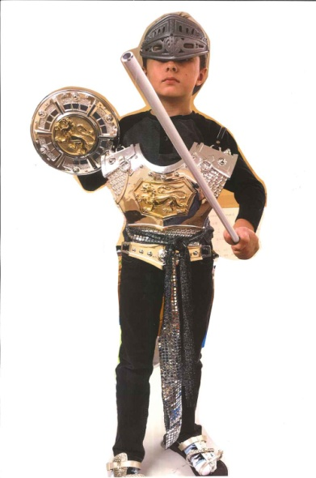

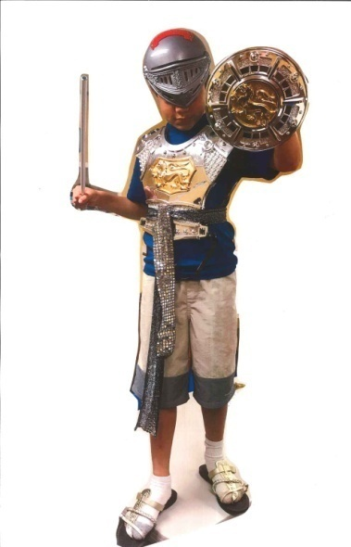
Scripture:

The Armor of God

Finally, be strong in the Lord and in his mighty power.

Put on the full armor of God, so that you can take your stand against the devil’s schemes. For our struggle is not against flesh and blood, but against the rulers, against the authorities, against the powers of this dark world and against the spiritual forces of evil in the heavenly realms.

Therefore put on the full armor of God, so that when the day of evil comes, you may be able to stand your ground, and after you have done everything to stand.

Stand firm then, with the belt of truth buckled around your waist, with the breastplate of righteousness in place, and with your feet fitted with the readiness that comes from the gospel of peace.
In addition to all this, take up the shield of faith, with which you can extinguish all the flaming arrows of the evil one.
Take the helmet of salvation and the sword of the Spirit, which is the word of God.

Ephesians 6:10-17

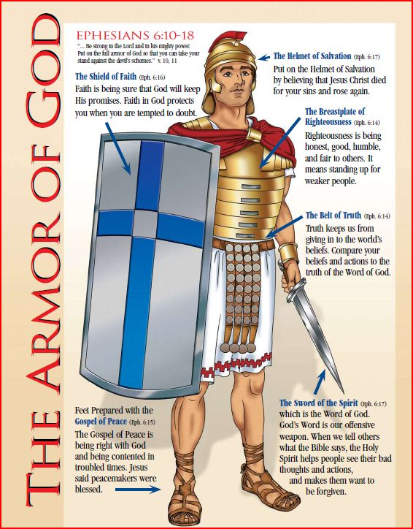
Lesson
Look up Ephesians 6:10-17 in your family Bible. Read the scripture aloud. Decide as a family, how you would like to use the material in this lesson to teach the Full Armor of God. You might break the lesson into two parts or teach your child about one piece of God’s Armor each day. If you are using the Full Armor of God Action sheet images provided, your child can add a piece of armor to their boy or girl coloring sheet each time you introduce a new piece of God’s Armor.
The Full Armor of God
Finally, be strong in the Lord and in his mighty power.
Put on the full armor of God, so that you can take your stand against the devil’s schemes. For our struggle is not against flesh and blood, but against the rulers, against the authorities, against the powers of this dark world and against the spiritual forces of evil in the heavenly realms.
Therefore put on the full armor of God, so that when the day of evil comes, you may be able to stand your ground, and after you have done everything to stand.” Ephesians 6:10-13

The Bible teaches us that God is our Protector. We can trust that God is in control. Because God is our Protector, he has given us something very special to help us. The Bible tells us to put on the Armor of God. The Armor of God will protect us when we are tempted to sin.
God and Satan are at war. Satan tries to get us to turn away from God by tempting us to sin. But, God loves us and wants us to be with him. If we love God and want to be with him, then we are in a fight, too. We are in a fight against sin, because sin takes us away from God. But, we don’t need to worry, because God is fighting for us and He has given us the tools we need to fight against Satan and win.
Think about how much better our lives would be if we woke up every day and put on the Armor of God. Learn to skillfully use the Full Armor of God to protect yourself from the schemes of the devil. With practice, you will be able to use God’s tools to “extinguish all the flaming arrows of the evil one”.

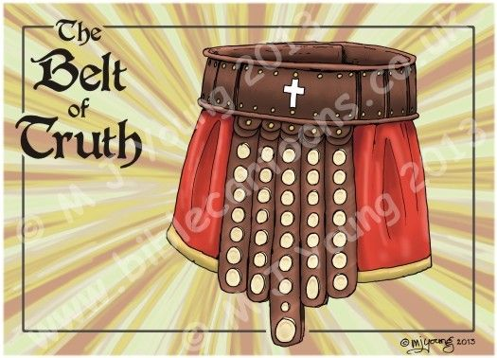
The Belt of Truth
“Stand firm then, with the belt of truth buckled around your waist” Ephesians 6:14

The Armor of God is our protection against temptation. It is our best defense against those who would try and turn us down the wrong path. We need to put on the full Armor of God if we want to live godly lives.
The Armor of God includes the Belt of Truth.
A warrior’s belt was very important as it took some of the weight off the warrior’s shoulders. It held the armor in place so it would not fall off during battle and most importantly it held the sword used to attack the enemy.
The Belt of Truth is essential to the Armor of God. It guides us along the straight path, avoiding sin. Just as a warrior’s belt holds the rest of the armor in place, the truth of God’s word is what guides all areas of our life.
God’s armor is something that we have to learn to put on every day by learning new things about God and changing our attitudes, how we think about life and other people.
The way to become one of God’s children is to learn the truth of God’s Word. God’s Word teaches us what sin is. It teaches us right from wrong and how we can lead a life that pleases God. Jesus wanted to show people the truth of God’s Word. When we remember these truths about God, we are putting on the Belt of Truth.

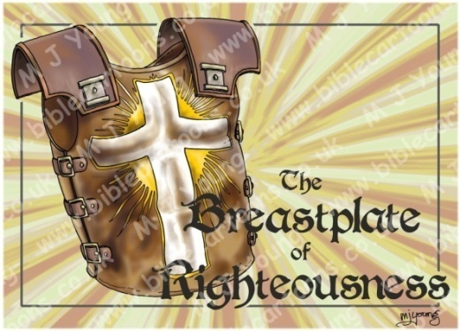
The Breastplate of Righteousness
“with the breastplate of righteousness in place” Ephesians 6:14

Satan tries to get us to sin, but since we love God, we don’t want to sin. We want to live righteous lives. Being righteous, means being right with God. We are righteous when we follow God and don’t let sin into our hearts.

The Armor of God includes the Breastplate of Righteousness.

The breastplate on a warrior’s armor protects his heart. The breastplate we get from God is called the Breastplate of Righteousness. This means that when we put on the Breastplate of Righteousness, we are protecting our hearts from sin.

We put on the Breastplate of Righteousness when we learn to be righteous or right before God. We learn how God wants us to live when we are praying and ask the Holy Spirit to direct our lives. When we read the Bible and memorize scripture we will learn to honor God’s commands. When we repent and ask God to forgive our sins we are telling God we want to be right before Him.

If we work to put on the Breastplate of Righteousness every day and follow God’s Commandments, then it will be really hard for Satan to lead us into sin. When we do what is right before God, we are putting on the Breastplate of Righteousness.

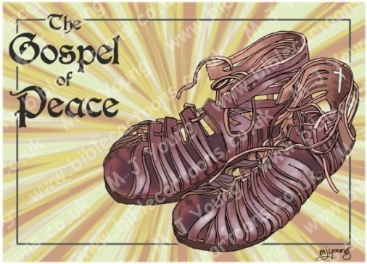
The Shoes of Peace
“with your feet fitted with the readiness that comes from the gospel of peace.” Ephesians 6:15

We are told to prepare our feet with the preparation that comes with the Gospel of Peace. When we put on these shoes and remember the gospel every day, we are able to follow Jesus and tell everyone we meet about God’s love.

What is the Gospel of Peace?
The Gospel of Peace is that Jesus came and died on the cross for our sins and then rose from the dead and ascended into Heaven. This means that if we believe in Jesus Christ and ask Him to forgive our sins, then we can live a peaceful life without worry. We don’t have to worry because we know we are going to Heaven.
Our job as warriors for God is to let as many people as we can, know about the Gospel. God tells us to be ready to share the “Good News” of the gospel. We can get ready to tell others by studying God’s Word, praying, learning about God at church, and talking to other Christians. Then we need to trust God. The Bible tells us the Holy Spirit will give us just the right words and the proper time to share them, if we allow God to help us. Luke 12:11-12
The shoes of the Gospel of Peace help us remember to follow Jesus. When we are following Jesus and doing what God wants us to do, we won’t have the desire to follow Satan. It is important to put on the shoes of the Gospel of Peace every day, so we can tell others about Jesus, and keep ourselves from following Satan.

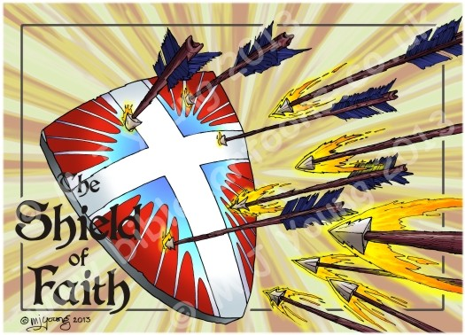
The Shield of Faith
“In addition to all this, take up the shield of faith, with which you can extinguish all the flaming arrows of the evil one.” Ephesians 6:16

The Shield of Faith moves to cover our doubts and struggles. The more faith we have in our Lord, the less likely we are to be hurt when Satan attacks. It is also important to remember that our God is always faithful to us. When we take up the Shield of Faith, we don’t do it through our own strength, but through God’s strength.
The Armor of God includes the Shield of Faith.
What makes the shield different from the other pieces of armor? Unlike the other pieces of armor, the shield isn’t strapped on to a certain part of your body. The shield can move to cover weaknesses in a warrior’s armor and keep arrows from piercing through. Great warriors know how to use their shield to protect them from danger. We need to do the same thing with the Shield of Faith.
Our Faith in God helps us when we are afraid, confused, troubled, or overwhelmed. It is through Faith that we trust God’s promises and trust Him to lead our lives and get us through difficult situations. We can trust God for He is always faithful.
The Shield of Faith is not only our faithfulness to God, but it is also God’s faithfulness to us. When we are faithful, it means we completely trust that God will protect us in our war against Satan. The problem is, when we doubt these things, we are not being faithful. That’s why God is faithful to us. He will never leave us. Even when we sin and doubt God, he is still there to protect us. When we believe that, we are picking up the Shield of Faith.

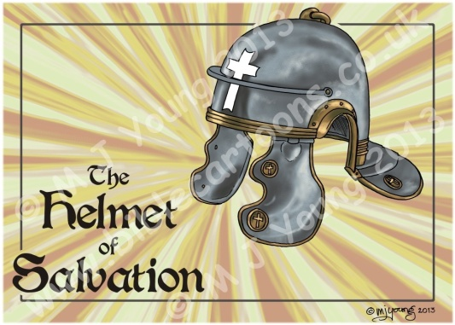
The Helmet of Salvation
“Take the helmet of salvation” Ephesians 6:17

As the helmet protects the head, our hope in salvation protects our mind from Satan’s lies. We need to remember and be confident in the hope we have in Jesus.

Why do we need to wear the Helmet of Salvation?
Warriors’ wear helmets to keep them from getting hurt in battle. One of our most important body parts is the head and one of the most important pieces of spiritual armor is the Helmet of Salvation. As we have been learning, we are in a spiritual battle against the devil and God has given us armor to protect ourselves.
Salvation is when Jesus comes into our lives and takes away our sins. Jesus saves us by forgiving our sins, and then we may be right before God. Salvation is the greatest gift we could ever receive because it took Jesus Christ dying on the cross for us to get to go to Heaven. God is so holy that He can’t be in the presence of sin. Sin keeps us from being near to God and entering Heaven. Jesus is the only way to get to Heaven. All we have to do is ACCEPT that we are sinners, BELIEVE Jesus Christ died for our sins, and CONFESS our sins to Him. Then we get to spend eternity with God.
Salvation is represented as a helmet because it protects our thinking. We are confident that we will spend forever in heaven because God has saved us through Jesus Christ. Sometimes when we sin, Satan tries to convince us that God will no longer love us and we are no longer saved. When Satan tries to trick us, we need to remember what Romans 8:37-39 tells us. These verses make it very clear that no matter what we do, after we put on the Helmet of Salvation, we belong to God.

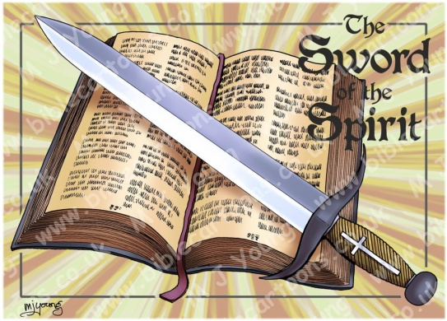
The Sword of Spirit
“the sword of the Spirit, which is the word of God.” Ephesians 6:17

The Sword of the Spirit is the Word of God or the Bible. This is an important piece of armor we must keep sharp and use daily. We must become “expert swordsmen!”
The Armor of God includes the Sword of the Spirit.
A sword is not a piece of armor a warrior puts on and wears. A sword is a weapon used in battle to personally fight the enemy. A skillful warrior knows how to use the sword to claim victory.
We can use the Sword of the Spirit in battle against Satan. The Bible tells us that the sword we use is the Word of God, the Bible.
God’s Word is alive and powerful. It exposes the truth. It helps us control our thoughts, actions and desires. A sharp sword can cut through just about anything. When we use the Bible as a sword, we are able to “cut through” the things the world tells us and get to God’s truth.
Did you know that even Jesus used the word of God as a sword against Satan? Read Matthew 4:1-11. After Jesus was baptized, he went into the wilderness and was tempted by Satan. When Satan tempted Jesus to sin, Jesus fought back by quoting from the Word of God. Jesus is the perfect example of a good swordsman. A good swordsman spends time practicing with his sword every day. He takes care to be sure his sword is always sharp. We can keep our Sword of the Spirit sharp by reading the Bible every day, memorizing Scripture and learning how to apply God’s Word in our life. With the help of Jesus, we can become “expert swordsmen!”

Material for this Lesson taken from: Ministry-To-Children, Armor of God for Kids "How to Win Against Sin" Bible Lessons, by Tara Tegard
https://ministry-to-children.com
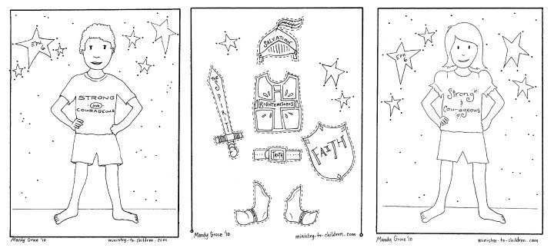
Time to have a little Fun
Full Armor of God Action Sheet
Locate the Armor-of-God-Coloring-pages link provided on the First Christian Church Website included with this lesson or go to the Ministry-to-Children link provided to copy the coloring sheets shown above.
https://ministry-to-children.com/armor-of-god-coloring-pages/
Print the picture of the boy or girl coloring sheet. Print the additions sheet which includes the pieces of the Full Armor of God. Encourage your child to color the Boy or Girl coloring sheet. Help your child color and cut out the Armor of God pieces. As you review the importance of the Full Armor of God, help your child attach the corresponding pieces of armor to their boy or girls coloring sheet.

Armor of God Memory Game
Locate the Armor of God Memory Game link provided on the First Christian Church Website included with this lesson. Print the cards. Cut the cards apart so you have 12 individual playing cards. Turn the 12 cards upside down. The first player picks up two cards. Read the fact card (or ask someone to read it). If the fact card matches the correct picture card which has the name of the armor, the player keeps both cards. If the cards do not match, the player places both cards upside down in their original places. The next player picks up two cards and tries to find a match. The player keeps the cards if they match and returns the cards it they don’t match. The game continues until all of the cards have been correctly matched together.

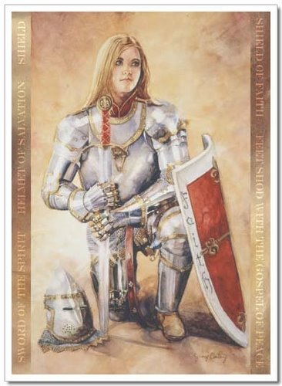

Closing Prayer

God,
Teach me to know Your truth. Help me make the right choices in everything I say or do. Teach me to have faith in You. Help me when I feel afraid or when I want to do something wrong. Teach me how to pray. Help me remember You every day. I never want to forget how Jesus died so I might join You in heaven someday. Teach me how to tell others the “Good News” that God love us and wants to help. Thank you for giving us the “Word of God” which is the Bible. Help me learn the Word of God so I can be the child of God You want me to become.
In the Name of Jesus,
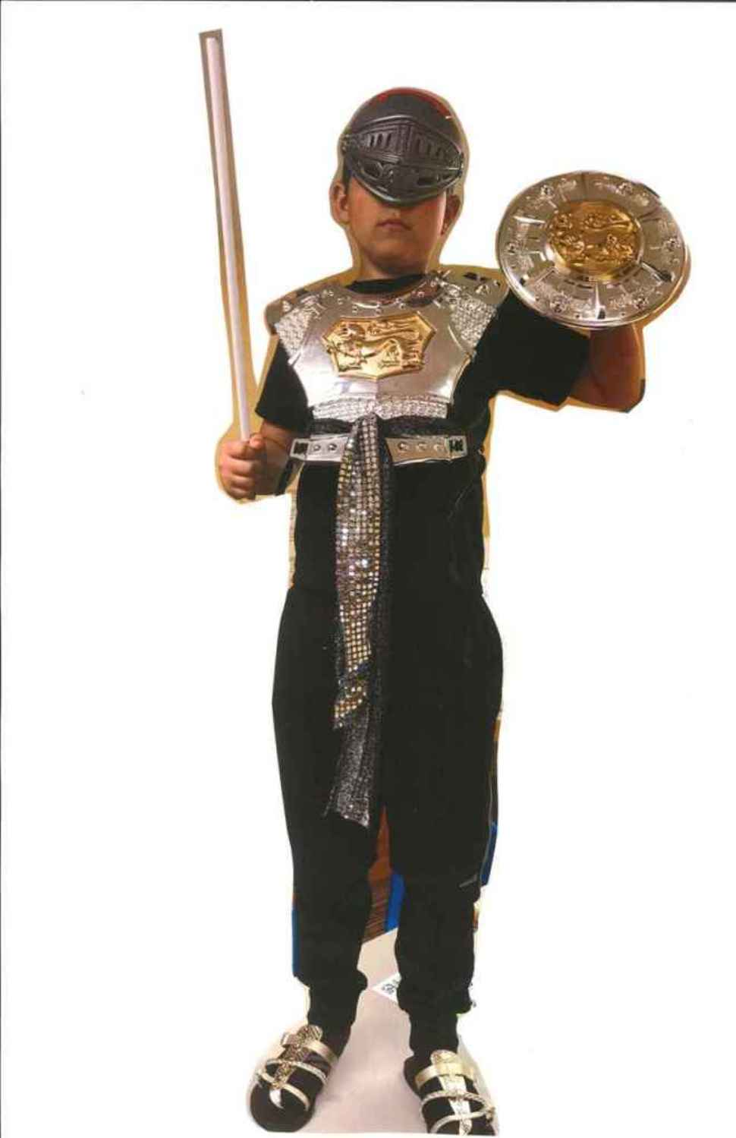
Amen
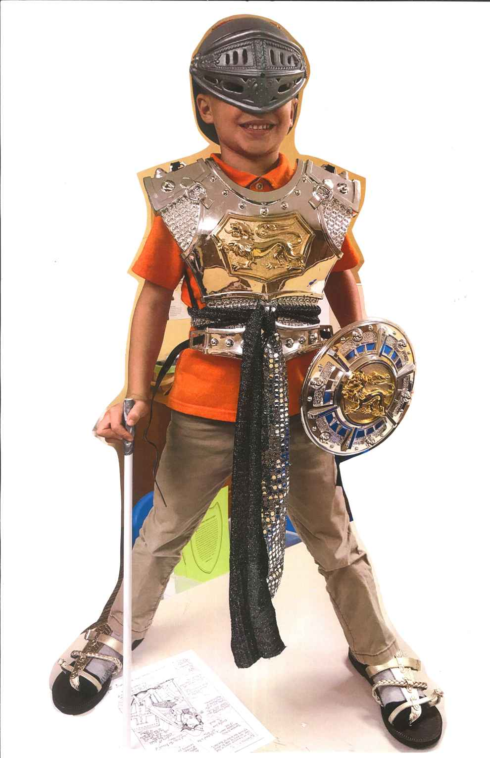
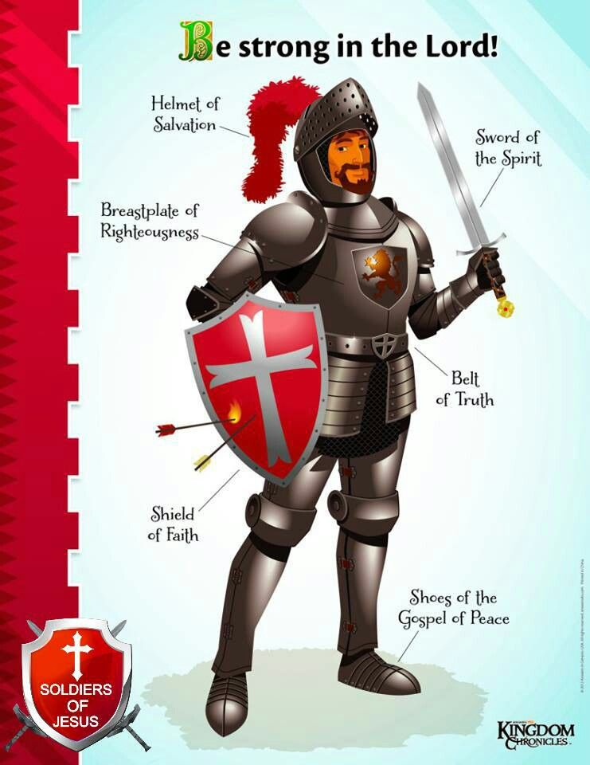

Check Out the Additional Attachments or Links:

- Use the Armor-of God -Coloring-Pages to add the Full Armor of God to a Boy or Girl Characters

- Use the Armor of God Memory Game to review what you have learned

- List all of the pieces of God’s Armor on the Armor of God Worksheet

- Search for God’s Armor in the Armor of God Word Search 1

- If you enjoy word searches, try this one also. Armor of God Word Search 2

