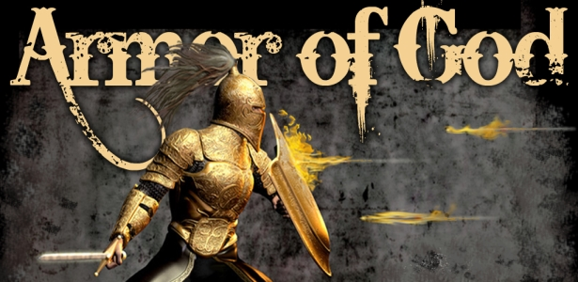

First Christian Church Sunday School Lesson
The Full Armor of God
Opening Prayer
God,
Thank you for loving us. You go before us and help us deal with everything that comes our way. There is nothing that surprises You. There is nothing You can’t handle. You have given us Your Son so we can be Your children. You forgive us from our sins and give us the Holy Spirit to guide us. The Word of God tells us to use the “Armor of God” which You gave us, to fight our battle with sin. Thank you Father, for giving us the tools we need to stay strong and close to You.
In Jesus’ Name we pray,
Amen

Praise and Worship
Check out these great dance moves.
Armor of God – Covenant Kids Worship
Stronger Week VBS Camp Song 2019
https://youtu.be/PZ5vIRy0cxw

You are never alone. God is with you, He surrounds you.
Michael W. Smith – Surrounded (Fight My Battles)
https://youtu.be/WamhEa4M7us
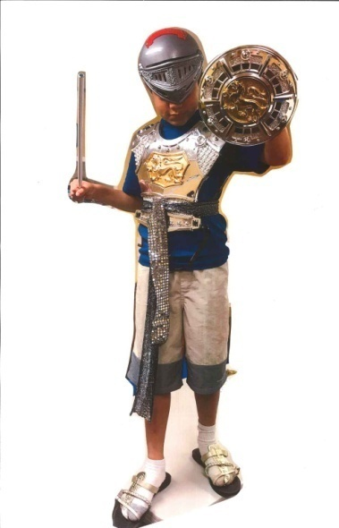
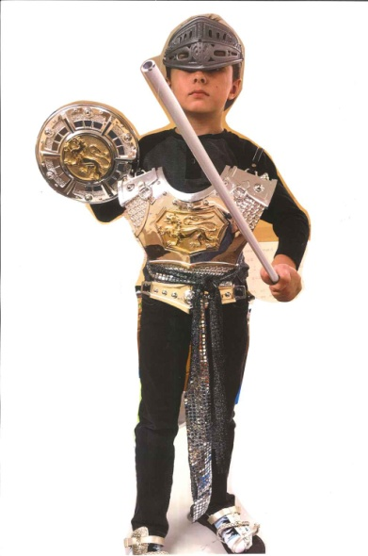

Scripture:

The Armor of God

Finally, be strong in the Lord and in his mighty power.

Put on the full armor of God, so that you can take your stand against the devil’s schemes. For our struggle is not against flesh and blood, but against the rulers, against the authorities, against the powers of this dark world and against the spiritual forces of evil in the heavenly realms.

Therefore put on the full armor of God, so that when the day of evil comes, you may be able to stand your ground, and after you have done everything to stand.

Stand firm then, with the belt of truth buckled around your waist, with the breastplate of righteousness in place, and with your feet fitted with the readiness that comes from the gospel of peace.
In addition to all this, take up the shield of faith, with which you can extinguish all the flaming arrows of the evil one.
Take the helmet of salvation and the sword of the Spirit, which is the word of God.

Ephesians 6:10-17

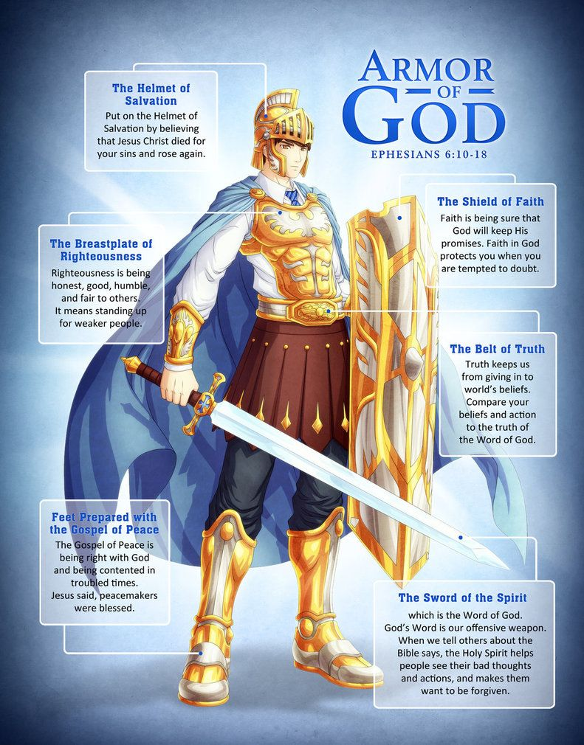
Lesson:

The Full Armor of God
Finally, be strong in the Lord and in his mighty power.
Put on the full armor of God, so that you can take your stand against the devil’s schemes. For our struggle is not against flesh and blood, but against the rulers, against the authorities, against the powers of this dark world and against the spiritual forces of evil in the heavenly realms.
Therefore put on the full armor of God, so that when the day of evil comes, you may be able to stand your ground, and after you have done everything to stand.” Ephesians 6:10-13

The Bible teaches us that God is our Protector. We can trust that God is in control. Because God is our Protector, he has given us something very special to help us. The Bible tells us to put on the Armor of God. The Armor of God will protect us when we are tempted to sin.
God and Satan are at war. Satan tries to get us to turn away from God by tempting us to sin. But, God loves us and wants us to be with him. If we love God and want to be with him, then we are in a fight, too. We are in a fight against sin, because sin takes us away from God. But, we don’t need to worry, because God is fighting for us and He has given us the tools we need to fight against Satan and win.
Think about how much better our lives would be if we woke up every day and put on the Armor of God. Learn to skillfully use the Full Armor of God to protect yourself from the schemes of the devil. With practice, you will be able to use God’s tools to “extinguish all the flaming arrows of the evil one”.

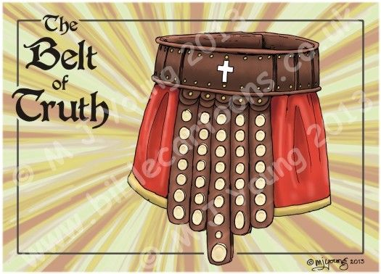
The Belt of Truth
“Stand firm then, with the belt of truth buckled around your waist” Ephesians 6:14

The Armor of God is our protection against temptation. It is our best defense against those who would try and turn us down the wrong path. We need to put on the full Armor of God if we want to live godly lives.
The Armor of God includes the Belt of Truth.
A warrior’s belt was very important as it took some of the weight off the warrior’s shoulders. It held the armor in place so it would not fall off during battle and most importantly it held the sword used to attack the enemy.
The Belt of Truth is essential to the Armor of God. It guides us along the straight path, avoiding sin. Just as a warrior’s belt holds the rest of the armor in place, the truth of God’s word is what guides all areas of our life.
God’s armor is something that we have to learn to put on every day by learning new things about God and changing our attitudes, how we think about life and other people.
The way to become one of God’s children is to learn the truth of God’s Word. God’s Word teaches us what sin is. It teaches us right from wrong and how we can lead a life that pleases God. Jesus wanted to show people the truth of God’s Word. When we remember these truths about God, we are putting on the Belt of Truth.

DISCUSSION QUESTIONS:
Read John 8:31-36
- How can we learn the truth of God’s Word?
- How does knowing the truth keep us from sin?
- Why is it important to know God’s truth?

Truth Questions
- How do you know when someone is telling you the truth?
- Is telling the truth always easy? Why/why not?
- If you use social media to talk to friends, is it easy to tell if others are telling the truth?

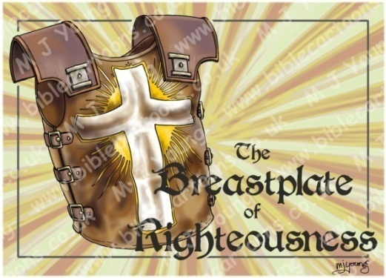
The Breastplate of Righteousness
“with the breastplate of righteousness in place” Ephesians 6:14

Satan tries to get us to sin, but since we love God, we don’t want to sin. We want to live righteous lives. Being righteous, means being right with God. We are righteous when we follow God and don’t let sin into our hearts.

The Armor of God includes the Breastplate of Righteousness.

The breastplate on a warrior’s armor protects his heart. The breastplate we get from God is called the Breastplate of Righteousness. This means that when we put on the Breastplate of Righteousness, we are protecting our hearts from sin.

We put on the Breastplate of Righteousness when we learn to be righteous or right before God. We learn how God wants us to live when we are praying and ask the Holy Spirit to direct our lives. When we read the Bible and memorize scripture we will learn to honor God’s commands. When we repent and ask God to forgive our sins we are telling God we want to be right before Him.

If we work to put on the Breastplate of Righteousness every day and follow God’s Commandments, then it will be really hard for Satan to lead us into sin. When we do what is right before God, we are putting on the Breastplate of Righteousness.

DISCUSSION QUESTIONS:
Read Psalm 119:9-11 and Deuteronomy 6:25

- What do the following verses tell us to do to stay righteous?

- How did you feel the last time you sinned?
At first it may have felt really good, but after a while, you probably felt pretty bad. That’s because when we sin, we aren’t wearing the Breastplate of Righteousness. This makes it even easier for Satan to come in and help us to sin more. Remember, we make the choice to let Satan lead us to sin.
- What are some of the Commandments that God wants us to follow?

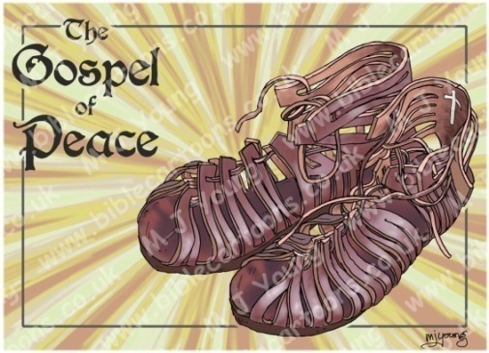
The Shoes of Peace
“ with your feet fitted with the readiness that comes from the gospel of peace.” Ephesians 6:15

We are told to prepare our feet with the preparation that comes with the Gospel of Peace. When we put on these shoes and remember the gospel every day, we are able to follow Jesus and tell everyone we meet about God’s love.

What is the Gospel of Peace?
The Gospel of Peace is that Jesus came and died on the cross for our sins and then rose from the dead and ascended into Heaven. This means that if we believe in Jesus Christ and ask Him to forgive our sins, then we can live a peaceful life without worry. We don’t have to worry because we know we are going to Heaven.
Our job as warriors for God is to let as many people as we can, know about the Gospel. God tells us to be ready to share the “Good News” of the gospel. We can get ready to tell others by studying God’s Word, praying, learning about God at church, and talking to other Christians. Then we need to trust God. The Bible tells us the Holy Spirit will give us just the right words and the proper time to share them, if we allow God to help us. Luke 12:11-12
The shoes of the Gospel of Peace help us remember to follow Jesus. When we are following Jesus and doing what God wants us to do, we won’t have the desire to follow Satan. It is important to put on the shoes of the Gospel of Peace every day, so we can tell others about Jesus, and keep ourselves from following Satan.

DISCUSSION QUESTIONS:
Read 1 Peter 3:15

- What does this verse tell us to do?

- What 2 words describe how we should do it?

Read John 14:27

- Where does our peace come from?

- How is this “peace” different than the peace the world gives us?

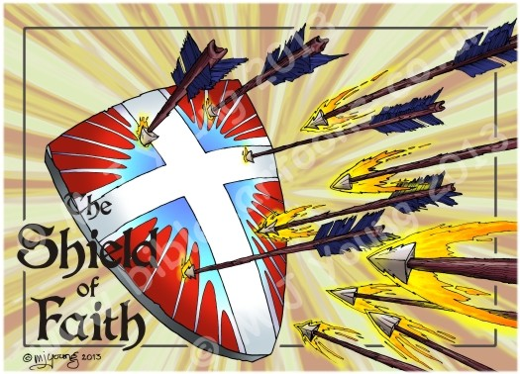
The Shield of Faith
“In addition to all this, take up the shield of faith, with which you can extinguish all the flaming arrows of the evil one.” Ephesians 6:16

The Shield of Faith moves to cover our doubts and struggles. The more faith we have in our Lord, the less likely we are to be hurt when Satan attacks. It is also important to remember that our God is always faithful to us. When we take up the Shield of Faith, we don’t do it through our own strength, but through God’s strength.
The Armor of God includes the Shield of Faith.
What makes the shield different from the other pieces of armor? Unlike the other pieces of armor, the shield isn’t strapped on to a certain part of your body. The shield can move to cover weaknesses in a warrior’s armor and keep arrows from piercing through. Great warriors know how to use their shield to protect them from danger. We need to do the same thing with the Shield of Faith.
Our Faith in God helps us when we are afraid, confused, troubled, or overwhelmed. It is through Faith that we trust God’s promises and trust Him to lead our lives and get us through difficult situations. We can trust God for He is always faithful.
The Shield of Faith is not only our faithfulness to God, but it is also God’s faithfulness to us. When we are faithful, it means we completely trust that God will protect us in our war against Satan. The problem is, when we doubt these things, we are not being faithful. That’s why God is faithful to us. He will never leave us. Even when we sin and doubt God, he is still there to protect us. When we believe that, we are picking up the Shield of Faith.
DISCUSSION QUESTIONS:
Read 1 Peter 1:3-9

- This verse explains that our faith must be refined. Why does our faith need to be refined or tested?

- What are you filled with, if you believe in Jesus even though you have not seen Him?

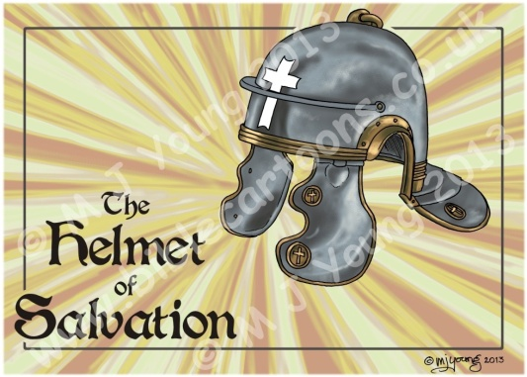
The Helmet of Salvation
“Take the helmet of salvation” Ephesians 6:17

As the helmet protects the head, our hope in salvation protects our mind from Satan’s lies. We need to remember and be confident in the hope we have in Jesus.

Why do we need to wear the Helmet of Salvation?
Warriors’ wear helmets to keep them from getting hurt in battle. One of our most important body parts is the head and one of the most important pieces of spiritual armor is the Helmet of Salvation. As we have been learning, we are in a spiritual battle against the devil and God has given us armor to protect ourselves.
Salvation is when Jesus comes into our lives and takes away our sins. Jesus saves us by forgiving our sins, and then we may be right before God. Salvation is the greatest gift we could ever receive because it took Jesus Christ dying on the cross for us to get to go to Heaven. God is so holy that He can’t be in the presence of sin. Sin keeps us from being near to God and entering Heaven. Jesus is the only way to get to Heaven. All we have to do is ACCEPT that we are sinners, BELIEVE Jesus Christ died for our sins, and CONFESS our sins to Him. Then we get to spend eternity with God.
Salvation is represented as a helmet because it protects our thinking. We are confident that we will spend forever in heaven because God has saved us through Jesus Christ. Sometimes when we sin, Satan tries to convince us that God will no longer love us and we are no longer saved. When Satan tries to trick us, we need to remember what Romans 8:37-39 tells us. These verses make it very clear that no matter what we do, after we put on the Helmet of Salvation, we belong to God.
DISCUSSION QUESTIONS:
Read Romans 8:37-38

- This verse describes what cannot separate us from the love of God. List three things.

- The Bible says sin separates us from God. What should we do so that does not happen?
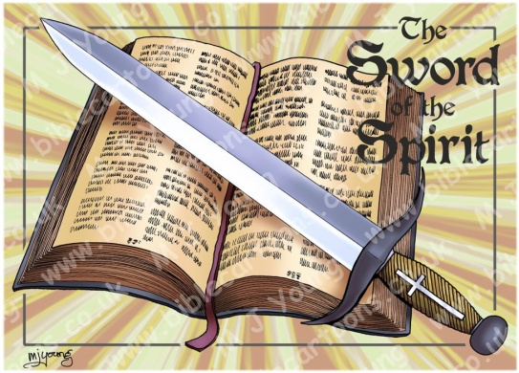
The Sword of Spirit
“the sword of the Spirit, which is the word of God.” Ephesians 6:17

The Sword of the Spirit is the Word of God or the Bible. This is an important piece of armor we must keep sharp and use daily. We must become “expert swordsmen!”
The Armor of God includes the Sword of the Spirit.
A sword is not a piece of armor a warrior puts on and wears. A sword is a weapon used in battle to personally fight the enemy. A skillful warrior knows how to use the sword to claim victory.
We can use the Sword of the Spirit in battle against Satan. The Bible tells us that the sword we use is the Word of God, the Bible.
God’s Word is alive and powerful. It exposes the truth. It helps us control our thoughts, actions and desires. A sharp sword can cut through just about anything. When we use the Bible as a sword, we are able to “cut through” the things the world tells us and get to God’s truth.
Did you know that even Jesus used the word of God as a sword against Satan? Read Matthew 4:1-11. After Jesus was baptized, he went into the wilderness and was tempted by Satan. When Satan tempted Jesus to sin, Jesus fought back by quoting from the Word of God. Jesus is the perfect example of a good swordsman. A good swordsman spends time practicing with his sword every day. He takes care to be sure his sword is always sharp. We can keep our Sword of the Spirit sharp by reading the Bible every day, memorizing Scripture and learning how to apply God’s Word in our life. With the help of Jesus, we can become “expert swordsmen!”

DISCUSSION QUESTIONS:
Read Hebrews 4:12

- This verse describes the Word of God in the Bible. Why do we need to keep our Sword of the Spirit sharp?

- How are you keeping your Sword of the Spirit sharp?

Material for this Lesson taken from: Ministry-To-Children, Armor of God for Kids "How to Win Against Sin" Bible Lessons, by Tara Tegard
https://ministry-to-children.com
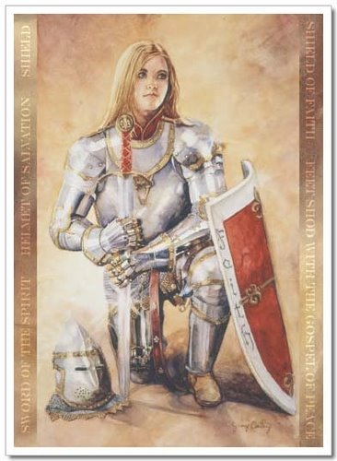

Closing Prayer
God,
Teach me to know and live by Your truth. Help me make the right choices so I will honor You in all my thoughts and actions. Show me how to be ready and willing to go and tell others about the good news of the Gospel. Father, strengthen my faith. Help me to use my Faith in You, to protect myself from doubts, fear, lies and deceit. Lord, I want to stay focused on You and never forget how Jesus died in my place so I might join You in heaven someday. Heavenly Father, thank you for the “Sword of the Spirit”, which is the Word of God. Let me learn Your Scriptures so I can use it when I stand my ground and hold true to my faith.
In the Powerful Name of Jesus,
Amen
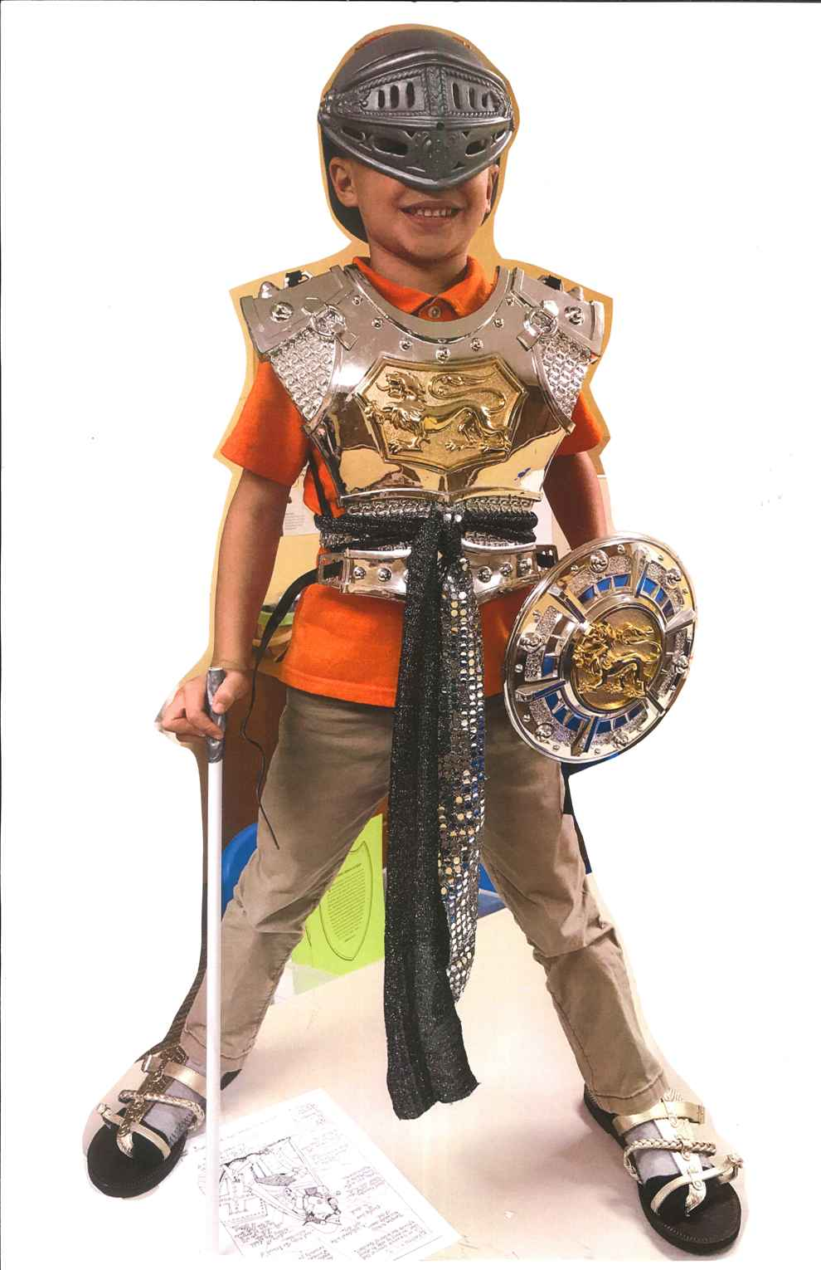
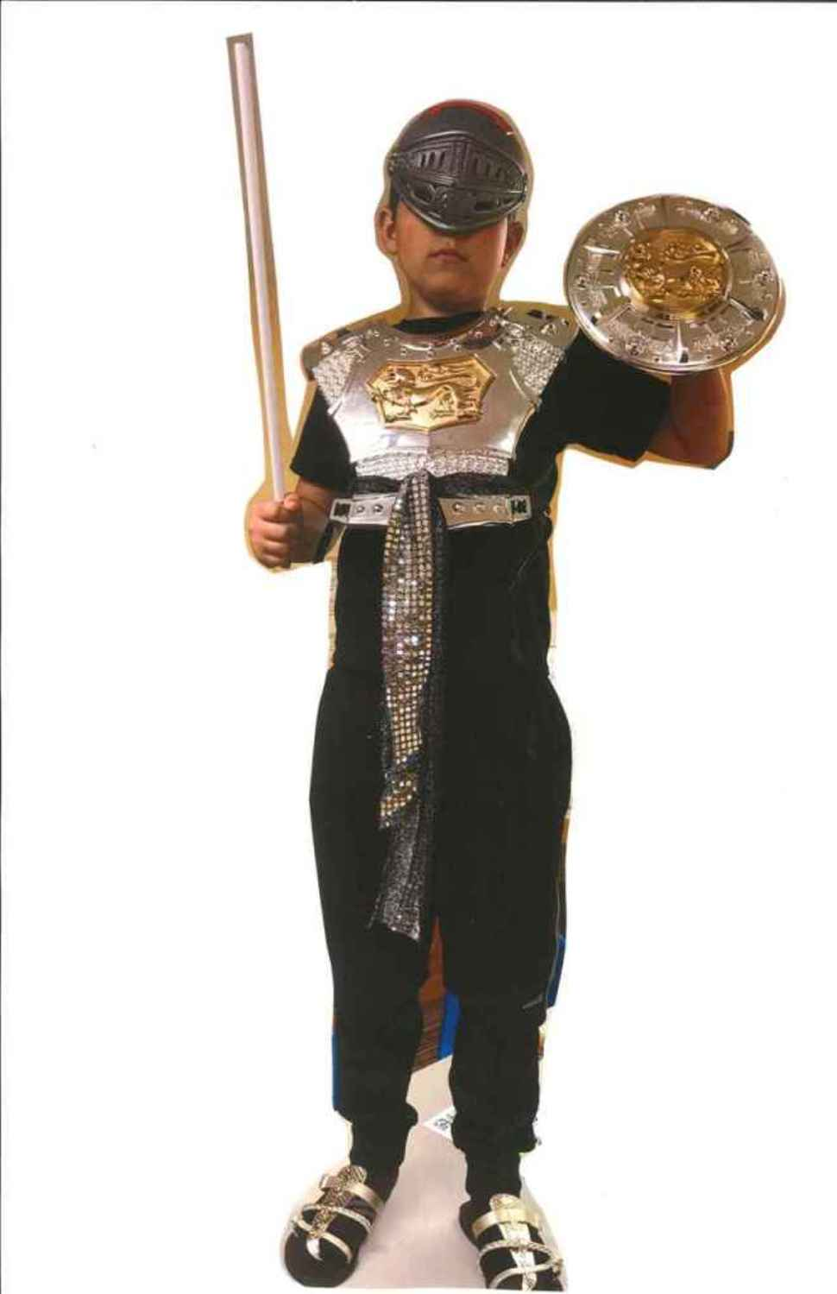

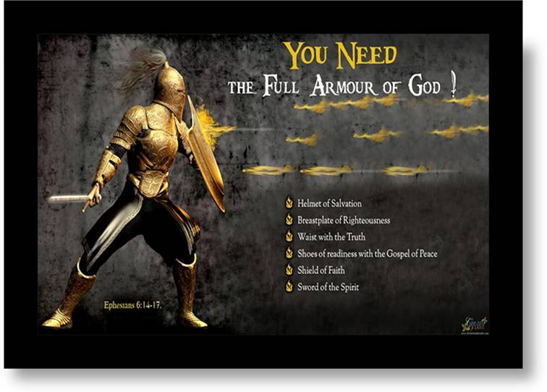

Check Out the Additional Attachments or Links:
- Use the Armor of God Bible Quiz to review what you have learned

- Search for God’s Armor in the Armor of God Word Search 1

- If you enjoy word searches, try this one also. Armor of God Word Search 2

- Relax as you color the Ephesians 6:11-18 Coloring Sheet – Boy
or Ephesians 6:11-18 Coloring Sheet –Girl

