First Christian Church Sunday School Lesson
Resurrection Sunday
Opening Prayer
Jesus,
Thank you for dying for me. Through your death, You have given me life, eternal life. Lord, help me believe in You in new ways. Help my faith grow stronger so I can tell others about the real meaning of Your Resurrection.
In Your Holy Name I pray,
Amen

Praise and Worship

This is a simple, catchy tune which will help you remember: Jesus died for you and me, but on day 3, Jesus Rose Again. Jesus is Alive!
Easter Kids Worship Music – Freedom Church KY
https://youtu.be/2gRqdvzFpP4

This song celebrates the “glorious day that Jesus washed our sins away. It is a “Happy Day” because we will never be the same…Jesus is Alive!
Happy Day (with Lyrics)
https://youtu.be/GirtIPZRZeg
Scriptures:

“He isn’t here!
He has Risen from the dead,
Just as He said would happen.
Come, see where his body was lying.”
Matthew 28:6a

If you declare with your mouth,
“Jesus is Lord,”

And believe in your heart that

God raised Him from the dead,

you will be saved.

Romans 10:9

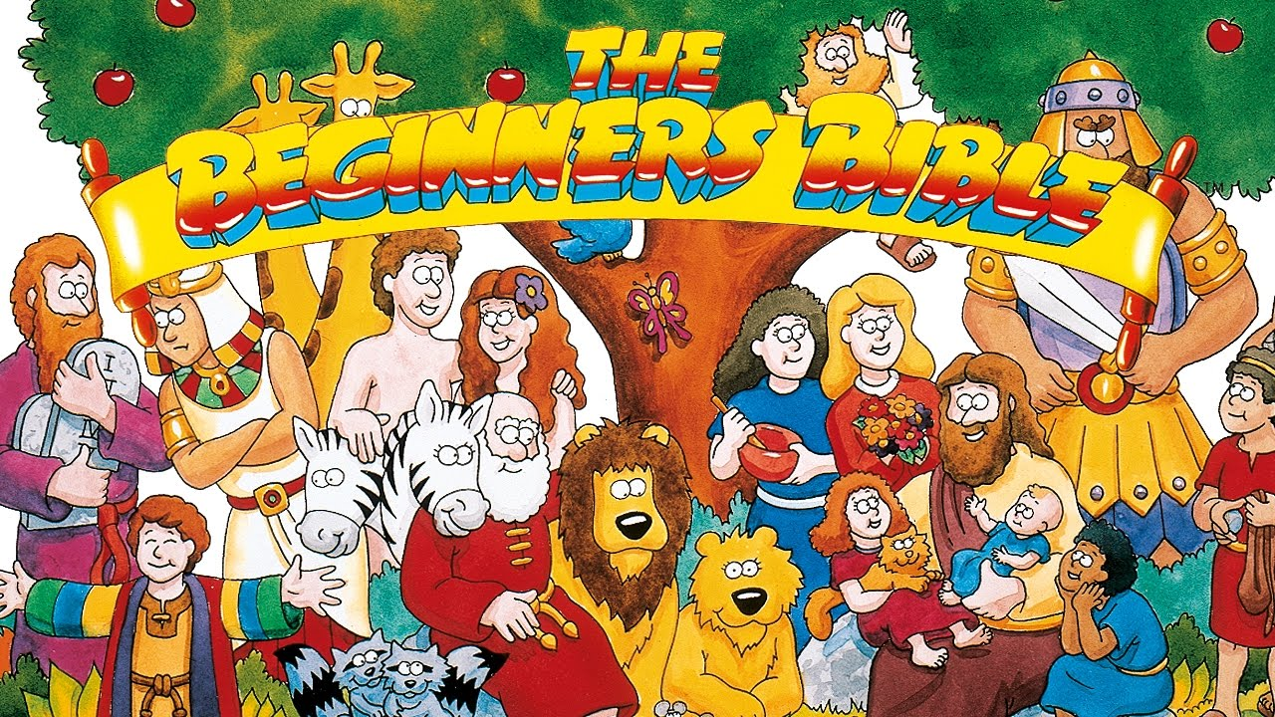

Lesson:
Resurrection Sunday helps us remember God’s special plan.
Jesus died to take the punishment for our sins, as God had promised He would. And because Jesus is alive, all people everywhere can have salvation and eternal life. When we believe that Jesus is God’s Son and that He died for us, our sins are forgiven and we can be part of God’s family!
Gather your family together and watch this special Easter Video.
This 30 minute video shares the account of Jesus from Palm Sunday to the Resurrection using a YouTube video from the Beginners Bible. It is a great way for young children to witness the Gospel and learn why Jesus died for us and rose again to fulfill His promise.

The Story of Easter – The Beginners Bible
https://youtu.be/0PSgoPdKQFQ

Time to have a little Fun
Tiny Bible Treasures - He’s Alive Coloring Book
The Bible tells us the account of Jesus death and resurrection. You can create your very own coloring book based on Matthew 28, Mark 16, Luke 24, and John 20. When you read your He’s Alive Coloring book, you will remember why Jesus died for YOU.
He’s Alive Coloring Book
Instructions to make your own Bible storybook:

- Open and Print the He’s Alive Coloring Book PDF file.
When printing, use the “shrink oversized page” feature so the book will fit on 8 1/2 – 11 sheets of paper.
- Cut each page in the middle along the black line.

- Assemble the pages in order and staple the left side to form your own He’s Alive Coloring Book.

- Ask someone to read this very special book to you.

- Enjoy coloring your new book about the Resurrection of Jesus.

Tiny Bible Treasures - He’s Alive Coloring Book Characters
Use these characters to tell the story of Jesus’ death and resurrection as told in the He’s Alive Coloring Book.
Characters for Retelling Instructions to make your own Characters for Retelling – He’s Alive:

- Open and Print the He’s Alive Flannelgraph PDF file.
You may choose the color or black and white file.
When printing, use the “shrink oversized page” feature so the images will fit on 8 1/2 – 11 sheets of paper.

- Color the characters if using the black and white file.

- Ask an adult to help you cut out each character.

- If you want your characters to stand up, glue a piece of cardboard to each page before you cut out the characters. Use play dough to make a stand for each characters. See the pictures below.

- Cut out the additional pieces such as the cave, stone, and trees.

- Ask an adult to read the account provided as you move the characters to retell the story of Jesus’ Resurrection.

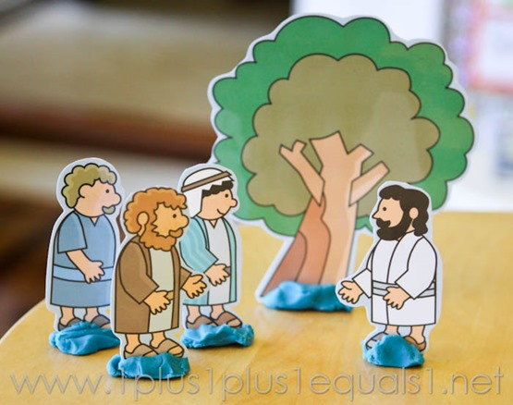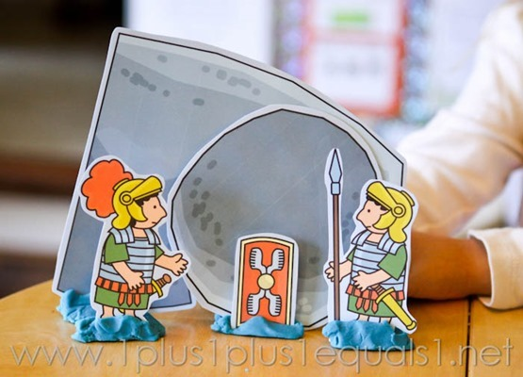

Closing Prayer
Jesus,
You love us in such an amazing way.
You came to earth to fulfill God’s plan to save us. Jesus, if we believe You are God’s Son and tell You we are sorry for our mistakes, You forgive our sins.
Your death was very sad, but it was the best gift You could have given us.
Now, we can talk to You when we pray. We can use the Holy Spirit to help guide and teach us. Every day, we can ask for forgiveness and You will take away our sins so we can stand before You as true Children of God.
You love us so much that You are preparing a place for us to spend eternity with You and the other believers who love You.
Thank you, Jesus. Your love is bigger than we can even imagine.
In Your precious name Jesus,
Amen

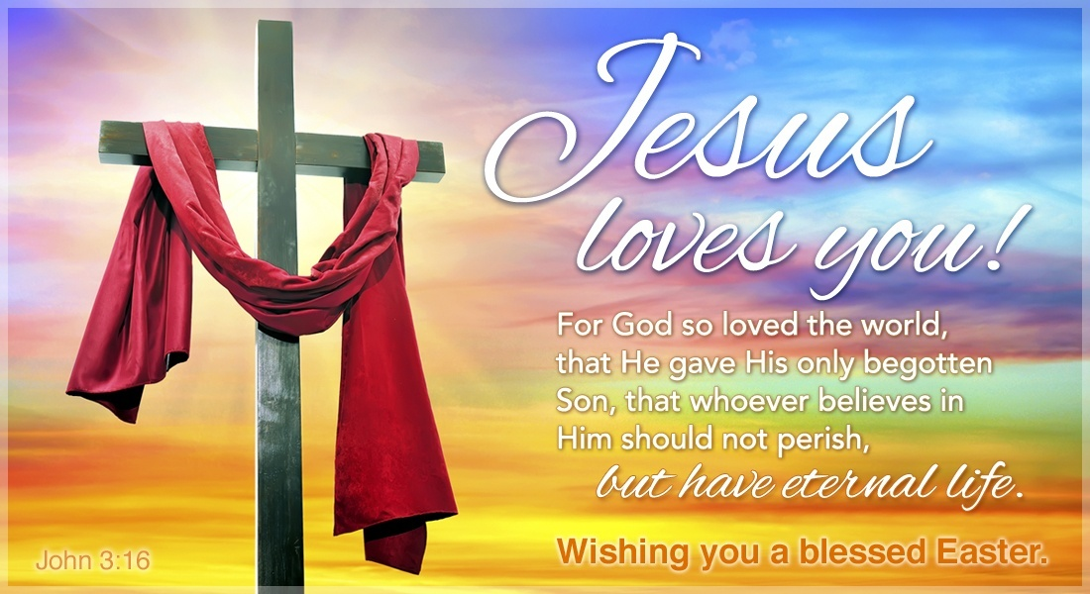

Check Out the Additional Attachments or Links:

- Make the He’s Alive Coloring Book to read about Jesus’ Resurrection

- Use the He’s Alive Flannelgraph Characters to retell the He’s Alive Coloring Book

- Bake “Empty Tomb” Rolls and enjoy a Resurrection treat

- Color the Resurrection Day Coloring sheet and see the empty tomb

- Find words from the account of the Resurrection in the Easter Word Search 1

- Children’s Prayer Calendar for April 2020
https://www.fcctillamook.org/sunday-resources.html

