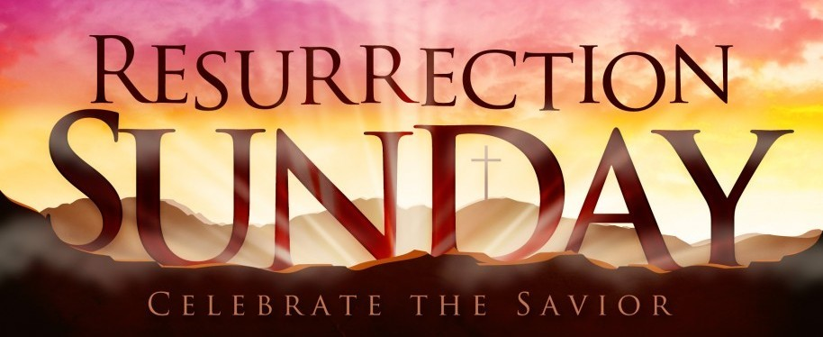
First Christian Church Sunday School Lesson
Resurrection Sunday
Opening Prayer
Jesus,
Thank you for dying for me. Through Your death, You have given me life, eternal life. Lord, help me believe in You in new ways. Help my faith grow stronger so I can tell others about the real meaning of Your Resurrection.
In Your Holy Name I pray,
Amen

Praise and Worship
Celebrate that Jesus is our Resurrected King. Sing “He is Alive” with this song.
Forever – Kari Jobe with (Lyrics)
https://youtu.be/KeJ14W2lXCw

A sweet song to remember the Love of Christ
In Christ Alone - Travis Cottrel
https://youtu.be/AjR_A2pGPrY
Scriptures:

But God
Demonstrates
His Own Love towards us.
In that while we were still sinners.
Christ died for us. Romans 5:8

If you declare with your mouth,
“Jesus is Lord,”

And believe in your heart that

God raised Him from the dead,

you will be saved.

Romans 10:9

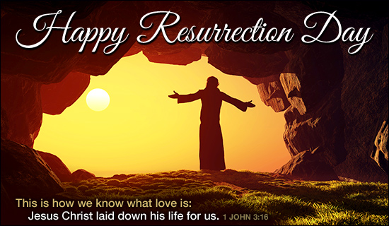
Lesson
Resurrection Sunday helps us remember God’s special plan.
Jesus died to take the punishment for our sins, as God had promised He would. And because Jesus is alive, all people everywhere can have salvation and eternal life. When we believe that Jesus is God’s Son and that He died for us, our sins are forgiven and we can be part of God’s family!
Gather your family together and watch the Gospel of John on this special Bible Project Video.

Bible Project
At the Bible Project, you may watch free animated videos that explore the books and themes of the Bible.
https://bibleproject.com/explore/

In Honor of Resurrection Sunday

I have included the links to the Gospel of John. During the YouTube video, you will see a visual map which clarifies the facts of the Gospel. Don’t miss Part II as it includes Jesus death, resurrection and the promise of our future with Him in heaven.

The Son of God
Not only is Jesus the Messiah, but He's also the Son of God who gives eternal life to everyone who believes in His name. We see this reality through the signs and miracles He performs, and seven times He answers "I Am" when people question His identity.
He also uses His time on earth to introduce people to the new birth. By believing that He is the Messiah and God's son, they have eternal life and freedom from sin and are empowered to perform radical acts of kindness, generosity and selfless love as they listen to His voice and obey Him.

John Part 1 – Chapter 1-12
Read Scripture Part I
https://youtu.be/G-2e9mMf7E8

John Part 2 – Chapter 13-21
Read Scripture Part II
https://youtu.be/RUfh_wOsauk

Go Deeper into God’s Word - Discussion Questions:
1. Why was Jesus the only One who could take the punishment for our sins?
(Jesus is the only person who never sinned. He is the One God promised to send.)

2. When we choose to become members of God’s family, what does God give us?
(We receive forgiveness for our sins and eternal life.)
Time to have some fun
With Your Family
Would You Rather Game
Print the 4 cards. Take turns having a family member read the words on the cards out loud so everyone sitting at the table can hear. Ask each family member to share their answer and explain why they chose their answer.
WOULD YOU RATHER…  HAVE JESUS WASH YOUR FEET  OR  HAVE JESUS SERVE YOU COMMUNION AT THE LAST SUPPER | WOULD YOU RATHER… SEE JESUS  WALK ON WATER  OR  SEE JESUS APPEAR IN A LOCKED ROOM WITH OUT USING A DOOR
WOULD YOU RATHER…  HAVE TALKED TO MARY MAGDALENE  OR  THE DISCIPLE PETER AFTER THE STONE HAD BEEN ROLLED AWAY | WOULD YOU RATHER… TOUCH THE HOLES  IN JESUS HANDS  OR  TOUCH THE LINEN THAT HAD BEEN USED TO WRAP JESUS BODY

Face To Face @ the Table
Choose one night during the week to talk “Face to Face” about a given topic or question. Turn off your electrical devices, phones, tablets or whatever devices could interrupt your time together. Join together around the table for a meal or just uninterrupted time together. Here are two questions you might ask your family and two questions you might discuss together.
ASK:
- During the crucifixion, the Bible tells us in Mark 15:31-32 (NLT): The leading priest and teachers of religious law also mocked Jesus. “He saved others,” they scoffed, “but he can’t save himself!” Let the Messiah, this King of Israel, come down from the cross so we can see it and believe Him!”
Why did Jesus die on the cross instead of using His power to save himself?
DISCUSS TOGETHER:
- Share three reasons Jesus had to die on the cross for us. Talk about why this was God’s plan from the beginning of time. Explain how Jesus sacrifice gave us the gift of forgiveness and the Holy Spirit to guide us. Luke 24:44-49

As a family read or say from memory the verse John 3:16 together.
“For God so loved the world that he gave his one and only Son, that whoever believes in Him shall not perish but have eternal life.”
As a family, talk about how Jesus’ death on the cross fulfilled the promise in this scripture.

ASK:
- What is Faith? (Hebrews 11:1 Faith is the confidence that what we hope for will actually happen; it gives us assurance about things we cannot see.)
DISCUSS TOGETHER:
- After Thomas saw the marks on Jesus’ hands and feet and touched the wound in His side, Jesus said to Thomas: “You believe because you have seen me. Blessed are those who believe without seeing me” John 20:27 & 29
Jesus’ disciples physically saw Him; they walked with Him, talked with Him and ate meals with Him. They personally witnessed Jesus heal sick people, perform miracles and fulfill His promise through the resurrection.
We have not physically seen Jesus, and yet we believe in Him.
What are three things you believe by FAITH? (Hebrews 11:1)

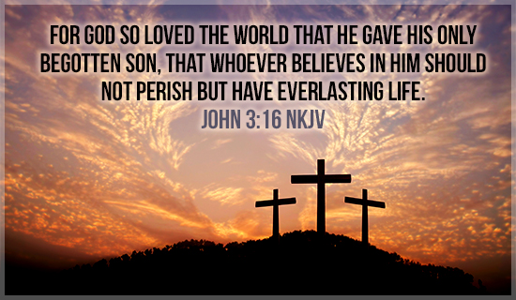

Remember, if we “Believe in Him” without personally seeing Jesus like the disciples did, we are blessed.
I am so thankful God gave us the Bible, the Holy Spirit, and other believers to help us “believe” in God and receive His promise of everlasting life.
Sermon by Harry Hewitt
My prayer journey (part 3)
Third installment: The power of prayer. 1980 was a pinnacle year. Another event happened that coincided with my weight loss. The very next day, I took Hope and Faith to the bus stop as we were living at 7120 Avenue space 22. My eyes kind of fuzzed over a little and I thought that maybe I needed to see Dr. Robinson, my optometrist. I went in that week and lo and behold, there was a special study taking part at the Devers Clinic in Portland. The program was paid for by the Federal Government because they were checking on people with diabetes. I have diabetes so I said, “Let us give it a try.” The study went on for 3 years and I went to the clinic every four months. It was called the ETDRS or Early Treatment Diabetic Retinopathy Study. Each treatment consisted of laser treatments to burn and close blood clots in my left eye. After three years, it stabilized and I was still able to drive.. Ironically some fifteen years later, my doctor said they accepted me, but they should not have accepted me because my optometrist was not legally trained enough. God really was working on my life and my family.
Every day, I walked home from school and to school the next day. On the weekends, Hope and Faith and I walked 1.8 miles around the loop up Fairview and out to the highway and back up by the Fairview Grange. It really kept me on target.
On our walks, we would sing Sunday School songs and the cows would follow us up the road. Then we would perform for them. It was a lot of fun every day. During those times we shared a lot of the usual family issues. The week Hope and Faith were at Junior Camp at Winema was the same week as the Tillamook County Fair. We had entered a contest and I called the girls to let them know that we won a trip to Disneyland. Wow, was that cool or what.
One of the prayers we asked about each day was to be able to move into town and out of the trailer park. Here is how it happened. It was so cool. We went on a second honeymoon, my wife Tanna and I got the girls to Vancouver B.C. On the way back, on the ferry, a driver got his foot stuck on the pedal and he rammed into the back of our car. At that moment, I grabbed my wife and the girls and said: “God is going to do something miraculous.” We finally got home to Tillamook as the car was drivable.
When we turned it in for insurance purposes, we got a check for $1588 dollars. We decided not to pay off any bills, because God was going to use it in a special way. At the time I was making $9,000 a year. Next week I will tell you how God answered our prayers. God is good. Yeah.

Closing Prayer 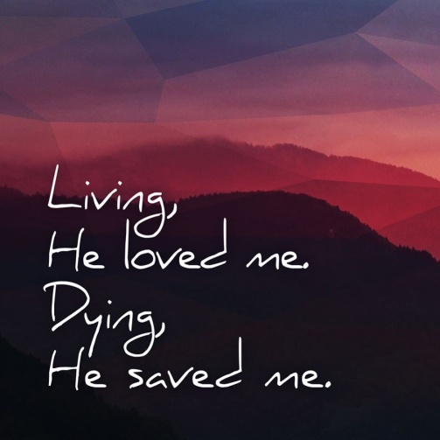
Jesus,
What amazing Love You have poured out on us.
You came to earth to fulfill God’s plan to save each of us. Jesus, if we believe You are God’s Son and tell You we are sorry for our mistakes, You forgive our sins. If we confess our faith and become baptized, then we are saved.
Your death was the greatest gift ever given. It allowed us to freely talk to You in prayer. When You returned to heaven, You provided the Holy Spirit to help guide and teach us. Every day, we can ask for forgiveness and You will take away our sins so we can stand before You as true Children of God.
You love us so much that You are preparing a place for us to spend eternity with You and the other believers who love You.
Thank you, Jesus. Your love is beyond measure, beyond human understanding and more than we can ever imagine.
In Your precious name Jesus,
Amen

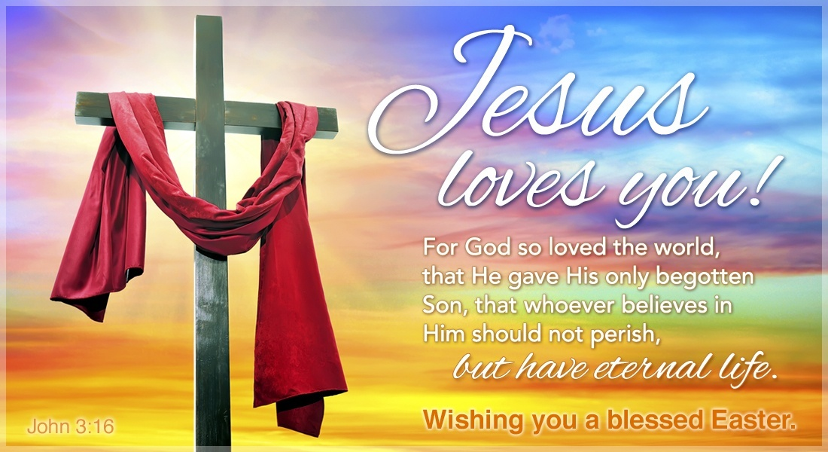

Check Out the Additional Attachments or Links:
- Bake some Resurrection Story Cookies for Easter morning

- Bake “Empty Tomb” Rolls and enjoy a Resurrection treat

- Use the Easter Crossword Puzzle to review what you have learned

- Find words from the account of Jesus’ Resurrection in the He is Risen Word Search

- Ready for a challenge, try the Easter Word Search 2

- Unscramble the names of people who were important in the account of Jesus’ Resurrection in the Resurrection Word Jumble

- Children’s Prayer Calendar for April 2020
https://www.fcctillamook.org/sunday-resources.html

