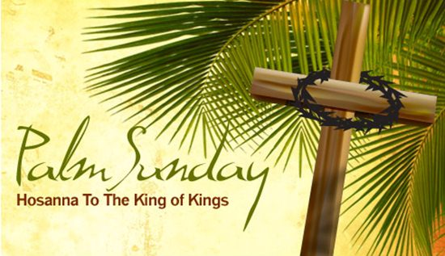
First Christian Church Sunday School Lesson
Palm Sunday
Opening Prayer
Jesus,
We want to praise you today. Thank you for everything you have made for us. Thank you for our families and friends. We are so happy that you care about us. Jesus, we know You will never leave us. We know you love us, because you sent Your only Son, Jesus to die for us.
In the powerful name of Jesus, Amen

Praise and Worship
Use the tune “Row, Row, Row, Your boat” to sing this song together.
Praise the Lord

Praise, Praise, Praise you, Lord.
How wonderful You are!
We come to praise Your mighty name.
We love You most of all!

Two great Hosanna! Songs on YouTube:
Steve Green –Hosanna! Matthew 21:9 & 1:1
https://youtu.be/wEUrQuiaMZQ

This is the YouTube Dean shared in his email.
Hosanna Praise Is Rising – Maranatha! Music
https://www.youtube.com/watch?v=ioL62cqH3iM

Scriptures For the Day
“How good it is to sing praises to our God.” Psalm 147:1

“Those who went ahead and those who followed shouted, “Hosanna!” “Blessed is he who comes in the name of the Lord!” Mark 11:9

Lesson:
Our Bible scripture tells us that Jesus deserves our praise. When Jesus lived on earth, some people praised him by waving palm branches and shouting “Hosanna!” Use the play, Jesus’ Triumphant Entry to share how people praised Jesus when He entered Jerusalem on a donkey. Gather some coats, make some palm branches and have fun learning about Jesus together.
Choose two or more members of your family who can read. Have one person read the part of the Narrator. The other members may read the additional parts. (Or one member can read all of the additional parts.) Remember to change your voice for the different characters.

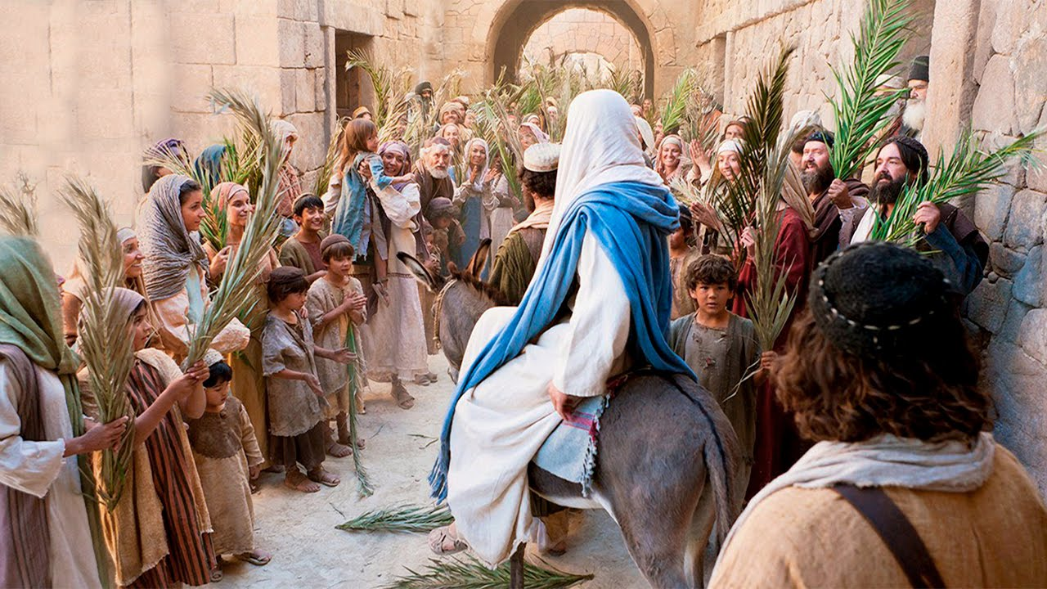

Jesus’ Triumphant Entry (Matthew 21:1-11, 15-16 and Mark 11:1-10)
Narrator: It was a special day. Jesus and his disciples were on their way to Jerusalem. The road was full of people who were walking to the Temple. When they came to a town near the Mount of Olives, Jesus asked two of His disciples to go ahead of them to a nearby village. Jesus told them.
Jesus: “As soon as you enter the village, you will see a young donkey tied there that no one has ever ridden. Untie it and bring it here. If anyone asks, ‘What are you doing?’ just say, ‘The Lord needs it and will return it soon.’”
Narrator: The two disciples left and found the colt standing in the street, tied outside the front door. As they were untying it, some bystanders demanded.

Bystanders: (surprised) “What are you doing, untying that colt?”

Narrator: The disciples said exactly what Jesus had told them to say, and they were given permission to take the colt.

Then they brought the colt to Jesus and threw their coats over the donkey’s back. Jesus sat on the donkey and began to ride into the city.
Narrator: This took place to fulfill the prophecy that said,
“Tell the people of Jerusalem,
‘Look, your King is coming to you.
He is humble, riding on a donkey—
riding on a donkey’s colt.’”

Narrator: As Jesus and his disciples headed towards the Temple, the crowd of people noticed Jesus was coming. A person in the crowd yelled out.
Person in the Crowd: “Look, Jesus is coming! Let’s cut some palm branches so we can welcome Jesus.”
Narrator: Most of the crowd spread their garments on the road ahead of Jesus, and others cut branches from the trees and spread them on the road. Jesus was in the center of the procession, and the people all around him were shouting. Then another person said.
Another person in the crowd: (pretend to takes off coat) “I am going to lay my coat on the ground to honor Jesus. Look at all the garments and palm branches lying on the ground for Jesus.

Narrator: The people all around Jesus were shouting.
“Praise God!”
“Blessings on the one who comes in the name of the LORD!”

People who love Jesus: (loudly sang) “Hosanna! Hosanna!”

Narrator: Jesus rode the donkey all the way into the city and up to the Temple. When the Temple leaders heard the children praising Jesus, they became very angry. They did not want to hear anyone praising Jesus. The temple leader yelled.
Leader in the Temple: (angrily) “Jesus, do you hear what these children are saying?”
Narrator: Jesus answered.
Jesus: “Yes. Haven’t you ever read the Scriptures?”
Narrator: Jesus told them, in the Bible it says, that the children and infants would be taught to praise Jesus. The children continued to sing “Hosanna” and praise Jesus. It was an exciting day in Jerusalem!

When you have finished, ask your children the following questions:

Discussion Questions:
1. What did Jesus say his disciples would find in the village? (a donkey or colt)
2. How did the disciples prepare the donkey for Jesus? (They laid their coats on the donkey’s back.)
3. What did the crowds spread on the road before Jesus? (coats and palm branches)
4. What did the people shout? Why did they do this? (They shouted “Hosanna, Blessed is He who comes in the name of the Lord!” because they were full of joy.)
5. If you were among the crowds, how would you have shown your joy when you saw Jesus?

Time to have a little Fun
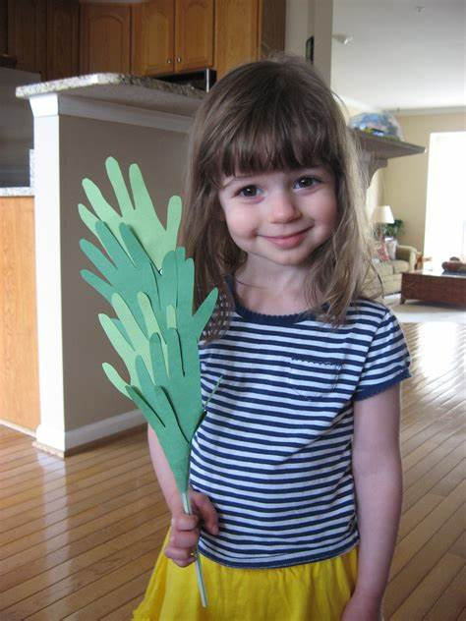 Grab your art supplies and create some palm branches. Here are just a few ideas to get you started. If you don’t have any green paper or paint, find some old magazines and let your children find pages with green images on them. Help your children cut out small pieces of green colored paper to glue in the shape of a palm branch.
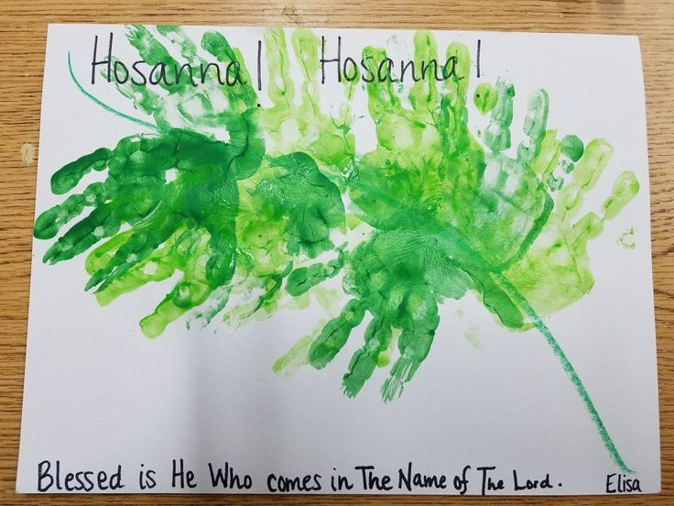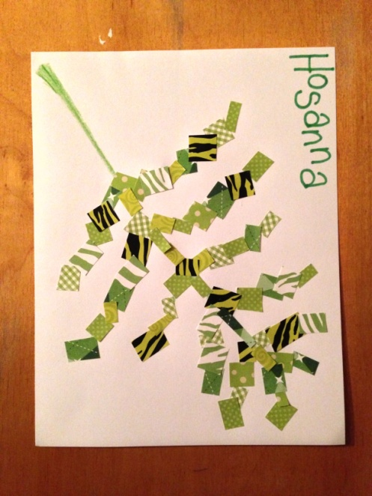

Have fun praising Jesus. Jesus deserves our praise.

Build a Road for Jesus 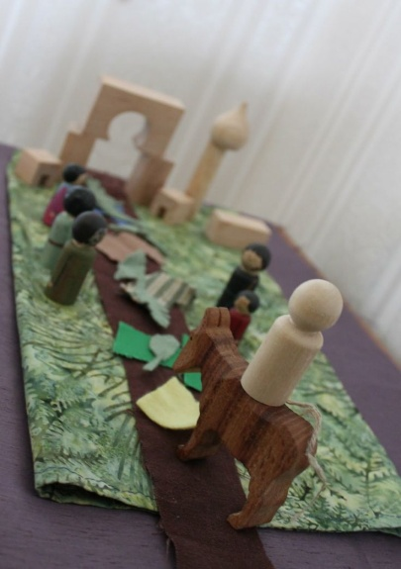

The Bible tells us that Jesus rode a donkey down a road into the city of Jerusalem. Use your Legos, blocks, or objects around your house to build a road. Gather some small leaves and colorful pieces of fabric or tissue. Use a Lego person or a small doll to show your family what happened when Jesus walked down the road during the “Triumphant Entry.”

Closing Prayer
God,
We are so glad we can praise you with our songs and words. Thank you for listening to each of our prayers. We know You love to hear your children say “thank you.” Heavenly Father, we praise you for this day and everything You have given us. Thank you for taking good care of us and our family. Please keep us safe. Jesus, we thank you for all the ways You love us. We know You saved us from our sins by dying on the cross. Thank you for loving us that much.
In the name of Jesus, Amen.
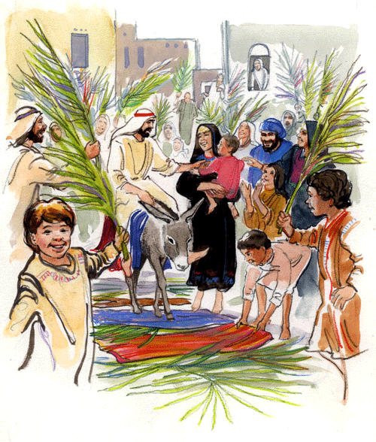
Check Out the Additional Attachments or Links:

- Use the Palm Sunday Color and Cut Out sheet – to retell the Triumphant Entry

- Find the special word in the Hidden Picture Coloring Sheet

- Use the Palm Sunday Maze to trace the steps of Jesus

- People Wave Palms to Jesus is a fun Word Search

- Children’s Prayer Calendar for April 2020
https://www.fcctillamook.org/sunday-resources.html

