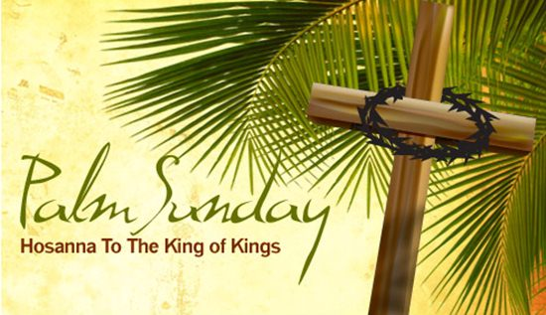
First Christian Church Sunday School Lesson
Palm Sunday - the Triumphant Entry
Opening Prayer
Jesus,
I praise You for being my King. Please rule over my heart. Jesus, please help me truly understand the gift you gave me when You died on the cross to take away my sins. Thank You for loving me and keeping all of Your promises.
In Your Holy name I pray, Amen.

Praise and Worship
This is the “Hosanna “YouTube Dean shared in his email.
Hosanna Praise Is Rising – Maranatha! Music
https://www.youtube.com/watch?v=ioL62cqH3iM

This is another great version of “Hosanna” by Paul Baloche
Paul Baloche – Hosanna
https://youtu.be/yFD3X-Sh6K4

Sing “Hosanna in the Highest” with Hillsong
Hillsong United – Hosanna with Lyrics
https://youtu.be/huwB3Ja_oJ4
Scriptures:
Rejoice greatly, O daughter of Zion!
Shout aloud, O daughter of Jerusalem!
Behold, your king is coming to you;
righteous and having salvation is he,
humble and mounted on a donkey,
on a colt, the foal of a donkey. Zechariah 9:9

“Those who went ahead and those who followed shouted, “Hosanna!” “Blessed is he who comes in the name of the Lord!” Mark 11:9

Something to Think About: 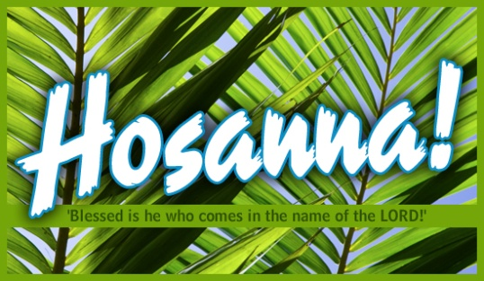
Written by Kristin Schmidt from Ministry-to-Children in her lesson entitled Holy Week Children’s Message –Jesus from Palm Sunday to the Last Supper
What about Jesus? What kind of leader was He? People had waited for His coming to Earth. They knew God had promised a king and a savior, and they probably had ideas about what kind of king He would be. They wanted someone to rescue them and make their lives better. At the time of His birth, the people of God were being bossed and bullied by Roman leaders, and they may have wanted Jesus to rescue them from the Romans. Perhaps they hoped that He would come galloping in on horseback and wipe out the oppressors. Maybe they expected Him to come with might and force. They wanted to make Him famous. That wasn’t quite how Jesus lived, though. He wasn’t born in a palace, but in a barn. He didn’t come swooping in on a horse and waving a sword. He came gently, riding on a little baby donkey! He came with peace and humility. When we talk about Palm Sunday, we celebrate that occasion, when Jesus rode a donkey into Jerusalem and crowds honored Him.
A Lesson about Palm Sunday:
Shared from Ministry-to-Children.com

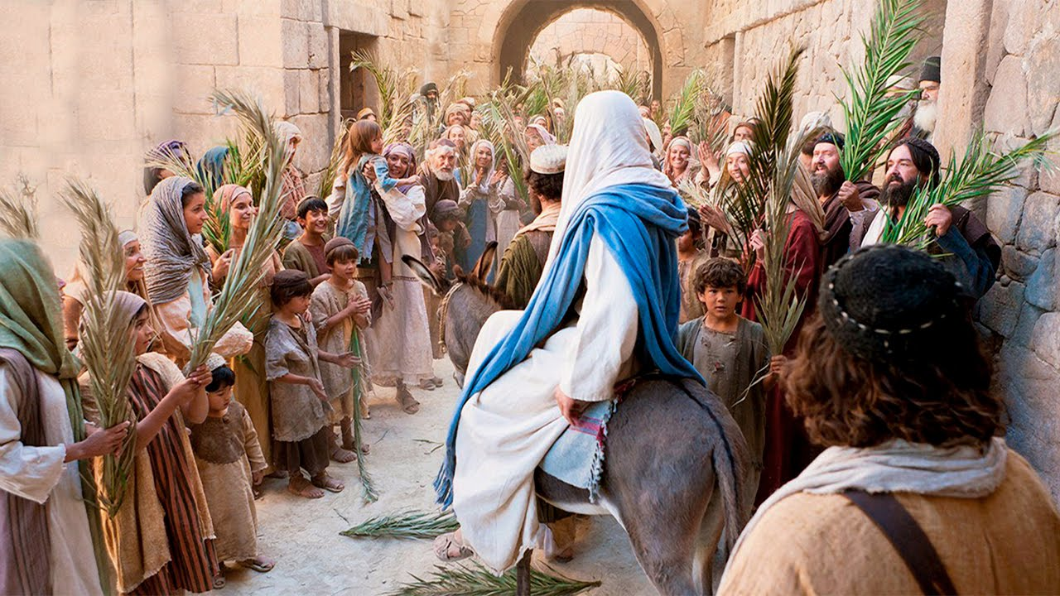
Read Matthew 21:1-11
Wow, this was a big parade – and Jesus deserved it. Remember how he had traveled all over Israel helping people, doing miracles, and telling them about God’s love. Now he was coming to the capital, the most important city. This was something the Bible had been promising for hundreds of years. It was all finally, coming together, and the people were going crazy like they had just won the super bowl.
But there was a problem: Jesus wasn’t rich like a normal king. He didn’t have a big fancy horse or a big fancy army to go with him in this parade. Did you hear how Jesus fixed that problem?
Read Matthew 21:1-3 again…
Matthew 21:1 As they all approached Jerusalem, they came to Bethphage. It was on the Mount of Olives. Jesus sent out two disciples. 2 He said to them, “Go to the village ahead of you. As soon as you get there, you will find a donkey tied up. Her colt will be with her. Untie them and bring them to me. 3 If anyone says anything to you, say that the Lord needs them. The owner will send them right away.”
Jesus and His disciples were walking towards Jerusalem when Jesus stops them. He sends 2 disciples to get Him 2 donkeys. But He doesn’t say anything about paying for them. They are to go to the village and get a donkey and her colt. If there are any problems…they are just supposed to say that “the Lord needs them” and it will all be fine.
But this wasn’t an accident. This was just what the Bible had promised for hundreds of years. The real king wasn’t going to be fancy, but ride into the city on a donkey … a donkey he had to borrow.
Read Matthew 21:4-5 again…
4 This took place so that what was spoken through the prophet would come true. It says,
5 “Say to the city of Zion,
‘See, your king comes to you.
He is gentle and riding on a donkey.
He is riding on a donkey’s colt.’ ” — (Zechariah 9:9)
Jesus was fulfilling prophecy. He was supposed to ride on a donkey’s colt – that means a young donkey. Can you imagine a big important king riding on a simple little donkey? What about the big army and the fancy horse? You see Jesus wasn’t a normal king trying to show he was important and force everyone to serve him. Jesus was the opposite: He came to show love and serve the people.
Read Matthew 21:6-9 again…
6 The disciples went and did what Jesus told them to do. 7 They brought the donkey and the colt. They placed their coats on them. Then Jesus sat on the coats. 8 A very large crowd spread their coats on the road. Others cut branches from the trees and spread them on the road. 9 Some of the people went ahead of him, and some followed. They all shouted,
“Hosanna to the Son of David!”
“Blessed is the one who comes in the name of the Lord!” — (Psalm 118:26)
“Hosanna in the highest heaven!”
The disciples did what they were told to do. They went and got the donkey and the colt. A big crowd was already showing up and covering the street with their coats and branches from the trees. Remember that they didn’t have paved roads back then – the roads were dirt. They were showing their respect to Jesus by covering the road so that He wouldn’t get dirty.
They cheered for Jesus with words from the Bible. This was a big victory celebration, and everyone was excited to see what would happen next.
That was a big commotion! I bet the people in the city were wondering what was happening.
Read Matthew 21:10-11 again…
10 When Jesus entered Jerusalem, the whole city was stirred up. The people asked, “Who is this?”
11 The crowds answered, “This is Jesus. He is the prophet from Nazareth in Galilee.”
Jesus made quite an entrance! People were trying to figure out who He was. Remember, there was no television back then. People had heard about Him, but they had never seen Him before. Notice – they didn’t say that He was the Son of God. They called Him a prophet. It was difficult for some of the people of Jesus’ time to realize that He was God and that He was going to save them. Even his disciples would be confused and abandon Jesus later that same week.
Discuss: Waiting for Jesus Again
The Bible says that Jesus will come again, but not in a parade on a donkey, but in the clouds in full glory. Describe what you think that might look like.
When Jesus comes again it will be to take his place as King of the world. This means we need to decide now if we will believe and follow Jesus. We need to be ready for his return.

Go Deeper into God’s Word 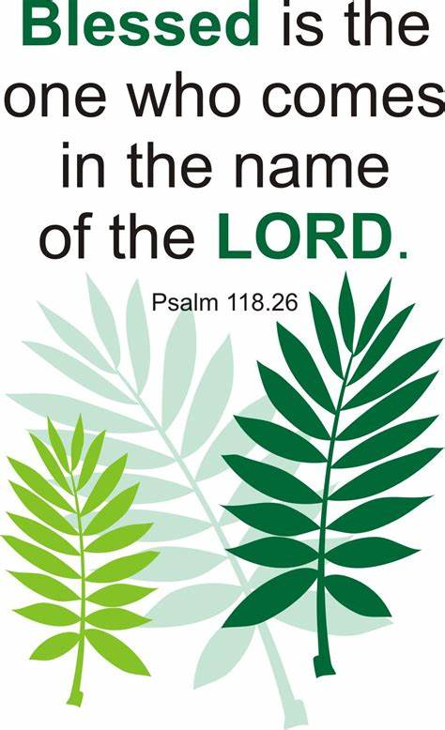
Discussion Questions:
1. What Old Testament passage is quoted in verse 5? (Zechariah 9:9.)
2. What Old Testament passage is quoted in verse 9? (Psalm 118:26.)
3. To a Jewish person, who knew these prophecies by heart, what would it mean to see Jesus fulfilling them? (It would have been overwhelming and inspiring.)
Time to have some fun
With Your Family
Would You Rather Game
Print the 4 cards. Take turns having a family member read the words on the cards out loud so everyone sitting at the table can hear. Ask each family member to share their answer and explain why they chose their answer.

WOULD YOU RATHER…  LAY DOWN YOUR COAT  OR  WAVE A  PALM BRANCH  WHEN JESUS RODE BY | WOULD YOU RATHER… WATCH LAZARUS BE RAISED FROM  THE DEAD OR  EAT WITH JESUS AT THE LAST SUPPER?
WOULD YOU RATHER… ANOINT JESUS’  HEAD WITH OIL  OR  WASH HIS FEET WITH YOUR TEARS? | WOULD YOU RATHER…  BE AT THE FRONT OF JESUS’ TRIUMPHANT ENTRY PROCESSION  OR  IN THE MIDDLE

Face To Face @ the Table
Choose one night during the week to talk “Face to Face” about a given topic or question. Turn off your electrical devices, phones, tablets or whatever devices could interrupt your time together. Join together around the table for a meal or just uninterrupted time together. Here are two questions you might ask your family and two questions you might discuss together.
ASK:
- During the Triumphant Entry, What did the people do to praise Jesus? (They laid their garments on the ground, waved palm branches, and sang “Hosanna!”)
- What words did they say to praise Jesus? (Blessed is He who comes in the name of the Lord.)
DISCUSS TOGETHER:
- What would you do to get ready if you knew Jesus was coming to visit our town?
- What would you say if Jesus walked right by you?

Sermon by Harry Hewitt
My prayer journey (part 2)
When you read the account of Jesus at the Garden of Gethsemane, he agonized to the point that he sweats blood. Remember, Jesus became a human being to please his Father. When he went to check on the disciples, they really were asleep. So, how does a person pray without ceasing? In my case, I started to read off of my prayer cards when I got hungry and that helped me to keep concentrating on losing the weight. As I got older, I began to be more willing to let people know that I was a Christian. When I taught at Tillamook High School from 1972-2000, I wrote on my chalk board: I AM A CHRISTIAN, IF YOU WOULD LIKE SOME COUNSELING, COME TALK TO ME.
Since I had all Seniors by 1977 and as I was teaching Government, I wrote those words to remind me that I had better practice what I preach. It is the same reason I wear the “GOT JESUS?” shirts. It is much like seeing a truck drive by and it says, “How am I driving? Call this number.” So I had better practice what I am saying to others. It made a difference in what I taught and how I conducted the classroom. Foul language was not permitted. I advised kids that they ought to look up the correct word rather than using cuss words. If they took the time to look it up they would not use it.
I can still remember the day that a football player picked up a Bible from my desk and asked a question in front of the whole class. ”You have said that it is not okay to be a queer or a same sex person. Where is that in the Bible?” Honest, I have no clue where I got the answer, but I did and it was in Leviticus 18. He read all of it and then closed the Bible and put it back. I know that Romans chapter one addresses the world we live in also and you might want to compare the two scriptures. It addresses the fact that we are all sinners and if we say we have not sinned, we just lied.
Do you remember learning the Ten Commandments: GIVESF/MMASLE. Prayer helps in learning how to use the Bible on a daily basis. Put God First, No idols before God, Do not use God’s name in vain, Keep the Sabbath Holy, Honor your Father and Mother, Do not commit Murder, Adultery, Stealing, Lying, and Envy.

In 1980, a real change came in my life. A gentleman in my Sunday School Class encouraged me to go to a seminar in Tigard, Oregon. From this seminar, and teaching time, I learned that the Bible cannot lie and that the earth is a little over 6,000 years old, not million or billion. The chances of being that old are 10 to the power of 250 and the term for that is GOOGUL. Try to work out the number and see how big that number is. The key is that the Bible cannot lie. Read 2 Timothy 3:16. God bless.

Closing Prayer
Jesus, You are our one and only true King. You rode into Jerusalem as our Prince of Peace, fully aware that You would be purchasing our salvation with Your blood. Thank You for Your great love. We praise You and adore You. We sing “Hosanna, Hosanna”, Save us, now, we pray, O Lord.
In Your mighty name Jesus, Amen

prepare your hearts for Easter:

- Read Matthew chapter 26-27, Mark chapter 14-15, or Luke chapter 22-23

- Memorize - Mark 11:9
And those who went before and those who followed were shouting, Hosanna! Blessed is he who comes in the name of the Lord!

- Bake Resurrection Cookies to share with your family on Easter morning.

- Write Jesus a “Love Letter” in your journal or on a piece of paper. Tell Jesus why He is worthy of your praise. Tell Jesus “thank you” for loving you so much that He would die on the cross for YOU.

- Tell someone why “Resurrection Sunday” is so important to Christians who believe in Jesus.

Check Out the Additional Attachments or Links:
- What does “Holy Week” mean? – What is Holy Week? Fact Sheet

- Use The Triumphal Entry Crossword Puzzle to review what you have learned

- Bake some Resurrection Story Cookies for Easter morning

- Children’s Prayer Calendar for April 2020
https://www.fcctillamook.org/sunday-resources.html

