This is a collection of ideas for making cards.
Send a Card to someone you Love.

…if you have a gift for showing kindness to others, do it gladly. Romans 12:8b

Send a Bouquet of Daisies or a Great Big Hug
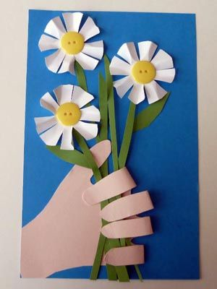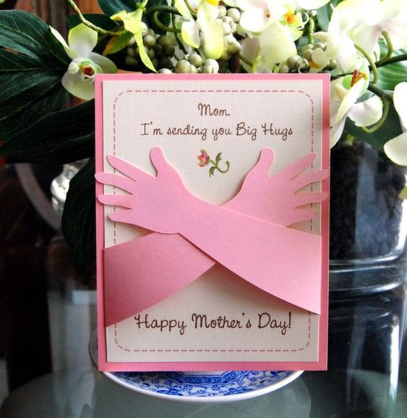
Send a Bouquet of Hearts or a Very Special Wish
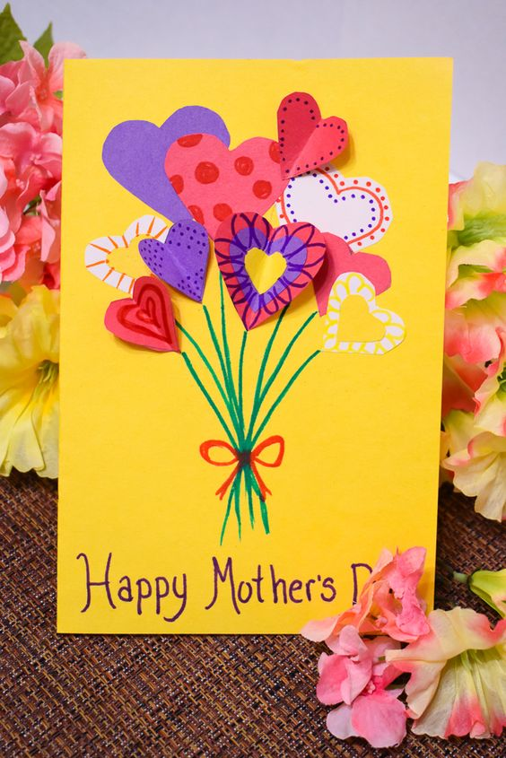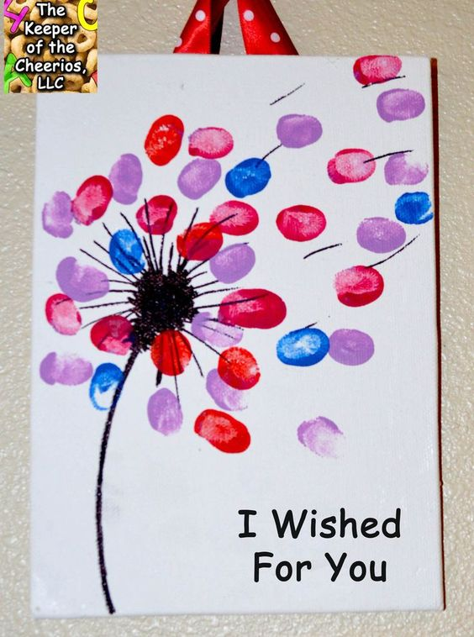
This is a great card to make if you have limited art supplies. All you need is an assortment of paper, a black permanent marker, scissors and glue. Have fun being creative.
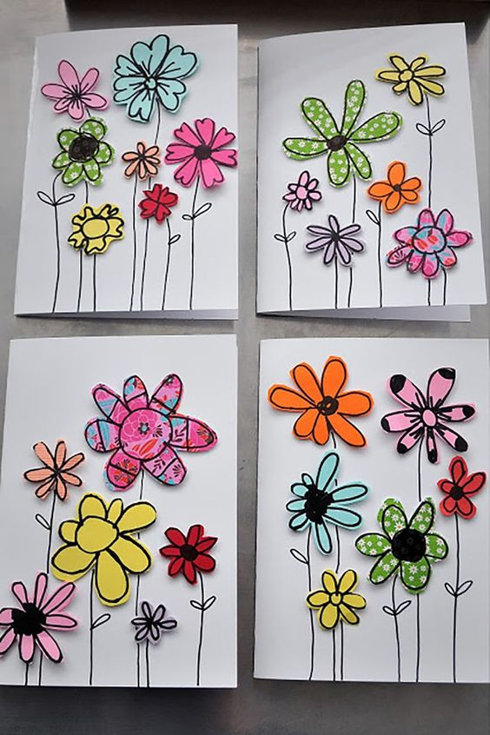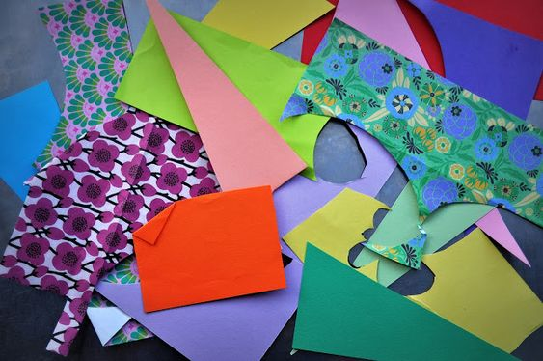
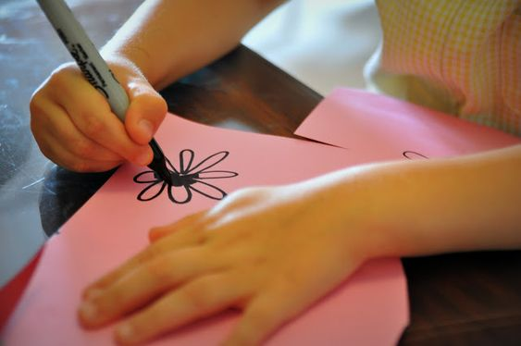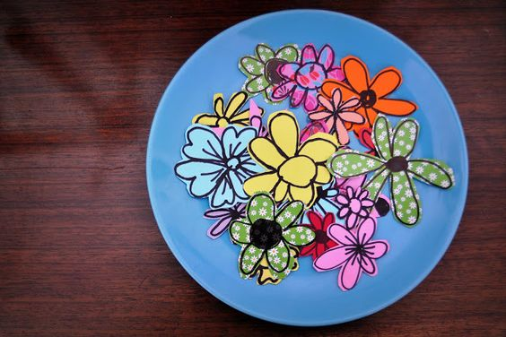
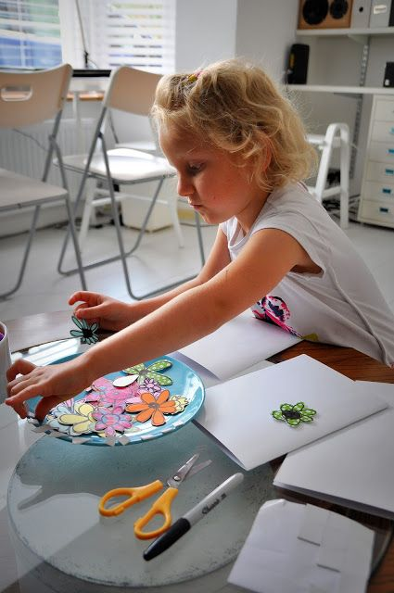 Have Fun! 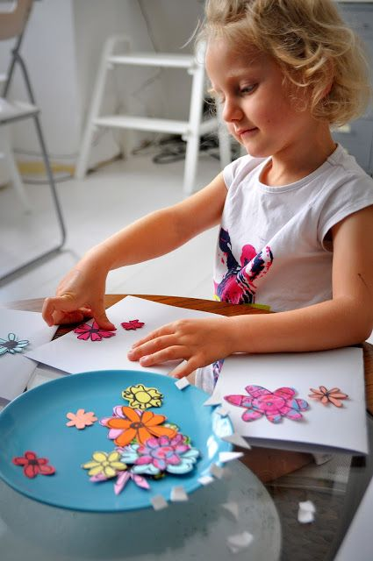

Use the bottom of a plastic bottle to print these cute flowers.
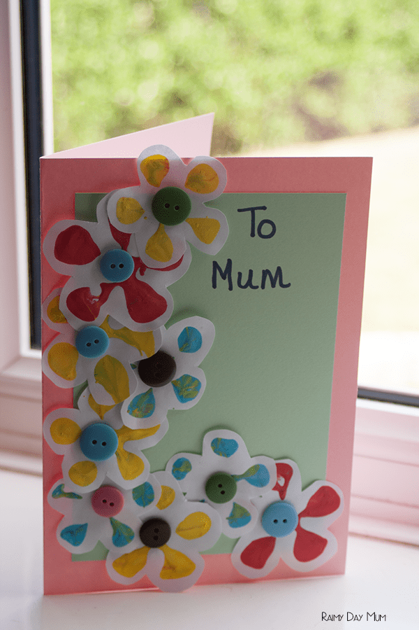 Simple Flower Stamped Card
Materials Needed:
- Plastic drink bottle with dimpled bottom like a Coca-Cola bottle. Try to find two different sized bottles so your flowers will be different sizes.
- Paint of a variety of colors
- White Paper to print on and colored Paper for making the Card
- Buttons
- Scissors
- Glue

Directions:
- Put paint in a paper bowl; dip the bottom of the plastic bottle into the paint.
- Using the painted end of the bottle, make an assortment of flower shaped prints on the white paper. Let the paper dry.
- Cut out the flower shapes, leaving white around the flowers for a border.
- Glue a piece of colored paper onto the front of your card. Use your flowers to decorate your card. Glue buttons in the center of each flower.
- Write your message inside your card and give it so someone you love.

