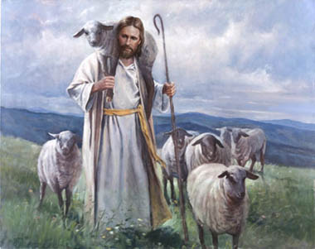
First Christian Church Sunday School Lesson for 3-22-2020

He is our Good Shepherd
Opening Prayer
Loving Father, we praise You today for all the ways You love us. You watch over us, guide us and protect us. You are a good shepherd. We ask You to be near us today as we learn from Your Word in the Bible. Jesus, help us learn to be more like you each day. We pray this in the Name of your mighty Son, Jesus,
In the name of Jesus, Amen

Praise and Worship
If you feel like singing to the Lord, try these YouTube videos.

Steve Green – When I am Afraid Psalm 56:3-4
https://youtu.be/nbAkKDBQoG8

A song from Wonder Kids - I am the Good Shepherd
https://youtu.be/jPgWagRSKgU
Scripture for the day
The LORD is my shepherd;
I have all that I need.
Psalm 23:1 (NLT)

“I am the good shepherd;
I know my own sheep,
and they know me,
just as my Father knows me and I know the Father.
John 10:14-15 (NLT)
Lesson:
God is always with you. He’s taking care of you like a shepherd takes care of his sheep. Shepherds make sure their sheep stay safe and have what they need. God is YOUR shepherd. Have someone in your family read Psalm 23 from your Bible.
Ask your parents what a shepherd does to take care of his sheep.
We are never alone, and we are never forgotten! Jesus said he is a good shepherd who takes care of his sheep. In fact, he laid down His own life to save us! When we feel afraid or discouraged, remember God’s promises in Psalm 23.

If you want to watch a shepherd taking care of sheep, watch this video.
https://youtu.be/Coq_grSFlNs 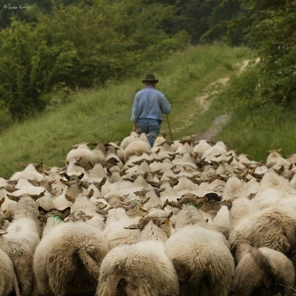
It reminds me of God’s promise in John 10:3-4 (NLT). Remember Jesus is our gatekeeper which is another name for shepherd.

The gatekeeper opens the gate for him, and the sheep recognize his voice and come to him.
He calls his own sheep by name and leads them out.
After he has gathered his own flock, he walks ahead of them, and they follow him because they know his voice. John 10:3-4

Ask your parents how you can talk to God so he hears your voice.
If you want to learn more about how God takes good care of you just like a shepherd, have your parents read John 10:1-18 from your Bible. Talk about how Jesus protects you and keeps you safe.
Time to have a little Fun:
God Hears Our Voice Game
- Ask your parents to help you set up a simple obstacle course in the center of the room using chairs, large stuffed animals, cardboard boxes or whatever non-breakable things you might have around.

- Ask your parent to use a soft towel to make a blindfold which will cover your eyes. Then ask your parent to use only his or her voice to guide you through the obstacle course.

- Then switch roles and see if you can guide your parent(s) through the obstacle course. Remember No peeking.

- How did it feel to trust in your shepherd?

- How was leading your parent through the obstacle course like being a shepherd?

- How does God take care of you? Ask your parents to tell you how God takes care of them.
God loves to take good care of us
Watch this sweet YouTube called The Good Shepherd with your family.
https://youtu.be/mDzuGZBq488

Closing Prayer
Heavenly Father, You are my good shepherd. You know my voice and my name. Your Bible tells me I should listen to You and follow Your Word or Bible. Jesus, I pray that others will learn to listen to You so they can be under your loving care. God, I thank you for loving my family each and every day.
In the name of Jesus, Amen

Check Out the Additional Attachments or Links:
- The Lord is my Shepherd Coloring Sheets
- The Lord is my Shepherd Crossword Sheet

- YouTube from Ministry-to-Children called A Message to Kids about Coronavirus
https://youtu.be/EIcgYCWCoa0

