First Christian Church Sunday School Lesson for 3-29-2020

God Hears our Prayers

Opening Prayer
Jesus,
You tell us we should pray when we are happy or sad.
Your Bible tells us to pray when we are thankful and when we need Your help.
Thank you for hearing our prayers when we are feeling scared or worried.
We can trust You, God, to hear every single prayer we say or think.
Thank you for loving us so very much. In the name of Jesus Christ, Amen
Praise and Worship
Action Prayer
Action prayers are a fun way for children to worship God.

God, You made every star in the evening sky. (Flick fingers in air like sparkling stars.)
You made the deep, blue sea. (Move arms like ocean waves.)
You take care of all your children (Point to others.)
And You take good care of me. (Point to yourself.)

Thank you, God, for every star in the sky. (Flick fingers in air like sparkling stars.)
And for the deep, blue sea. (Move arms like ocean waves.)
Thank you for loving all your children. (Point to others.)
And for taking such good, care of me. (Hug yourself.)

YouTube Songs Celebrating Prayer:
Jesus said, “Let the little children come.” Steve Green has great videos of Kids.
Steve Green - Hide Em In Your Heart Song - Matthew 19:14
https://youtu.be/wqe4xkD6FVk

Listen to children saying the Lord’s Prayer with sweet pictures in the background.
The Lord’s Prayer for Children – Our Father
https://youtu.be/O78UfDkGhRs

Learn to sing the Lord’s Prayer.
Our Father Lord’s Prayer 3
https://youtu.be/UwvBtcwPQS8
Scriptures for the day
Psalm 118:29 Pray to say Thank You
Give thanks to the LORD, for He is good; His love endures forever.

1 Peter 5:7 Pray for Help
Cast all your anxieties on Him, because he cares for you.

1 John 1:9 Pray for Forgiveness
If we confess our sins, He is faithful and just and will forgive us our sins and purify us from all unrighteousness.

Lesson:
God hears our Prayers. God listens to the prayers of our children also. We want our children to know they can pray to God whenever they want to feel Him near. We want our children to trust they can share their needs, fears, and concerns with God, by simply having a conversation with their Heavenly Father. If our children need wisdom, we want them to understand how to pray for God’s direction in their lives. We want our children to learn the importance of thanking God through prayer as well as experience the joy of forgiveness when they ask God to forgive them in prayer. Prayer is a very special gift God has given each of us.
Here are some simple ways you can help your children learn to pray:
- Ask God to help you teach your children how to pray. Pray that God will help your children develop a strong faith and give them a desire to pray.

- Set a good example. Pray with your family before meal time and before you tuck your children into bed. Let your children see that you trust God to hear your prayers. Let your children over hear your prayers of praise, forgiveness and need.

- Take time to pray every day. Use the Children’s Prayer Calendar to pray with your children each day in April. If you did not receive a calendar in the mail, you may use the link https://www.fcctillamook.org/sunday-resources.html on the First Christian Church Website to copy one for your family.

- God says to pray continually, so take time for spontaneous prayers. If you lose your keys or your temper, stop and pray aloud with your kids about it. If you learn that someone is sick, let your children join you in praying for God’s protection and healing.

- Use visual model to help you remember to pray for others. Use the Powerful Prayer Poster to list names of people your family or your children would like to pray for. Download and copy the Powerful Prayer Poster attachment provided.

- Celebrate Answered prayers. Take time to share with your children how God has answered your prayers in the past as well as recent prayers. You might write answers to prayers on colorful rocks and collect them in a large glass vase.

- Teach your children the prayer that Jesus gave His disciples. The Lord’s Prayer, Matthew 6:9-13 is a perfect example of how we can all pray to our Father in Heaven.

Here are some additional ways to Pray with your children:

- Look through a family photo book with your children. Pray for family members as you look at the pictures together. Take time to call a family member and ask if they have any specific prayer request.

- When you tuck your children into bed, tell your children one way you’ve seen God working during the day. Pray and ask God to show you how He is working in your family, in your church, in your neighborhood and in the world.

- Use a marker to make a red dot on the hands of those praying together. First, pray quietly and ask Jesus to forgive you for anything you have done wrong. Then wash your hands with soapy water and scrub the dots away. Pray together as you thank Jesus for taking your sins away.

- When you are walking in your neighborhood, think of neighbors or friends who don’t know about Jesus. Pray that God will use you or others to share God’s love and hope with them.

- Ask your children to tell you what they know about Heaven. Remind your children that Jesus went to heaven to prepare a place for everyone who believes in Him and loves Him. Together, thank God for loving you enough to spend eternity with you.

Time to have a little Fun: 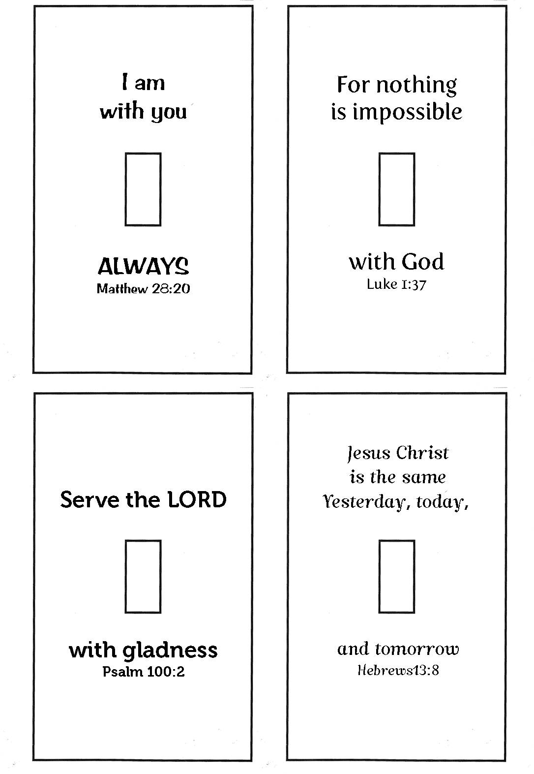
This is a fun way to remind your family to pray each day.
Use the Scripture Switch Plates activity to make fun reminders for your family.
- Copy the attachment titled -Scripture Switch Plates. (Word Doc or jpg)
- Let members of your family decide which switch plate they would like to color.
- Cut the switch plates out and use tape to secure them to the light switch plates around your home.
- Each time you turn on or off the light, take time to remember God’s Word and Thank Him for His promises.
- When you turn the lights on, remember Jesus is the light of the World.

Closing Prayer
Use the tune of Jesus Loves Me to sing this prayer.

God Hears Me Prayers
I can talk to Jesus today,
He is with me every day.
He is listening when I pray.
Jesus hears every word I say.
Chorus:
Yes, Jesus, hears me
Yes, Jesus, hears me
Yes, Jesus, hears me
He hears me when I pray.

Check Out the Additional Attachments or Links:
- Children’s Prayer Calendar for April 2020
https://www.fcctillamook.org/sunday-resources.html

- Remember to pray for others using the Powerful Prayer Poster activity sheet.

- Use a code to unscramble Psalm 107:1 – Our Friend, Jesus activity sheet.

- Unscramble the message of James 5:16 and remember to Pray For Each Other.

