The **Shield of Faith** is lifted up to protect you and to extinguish all the flaming arrows of the evil one.

You will need a strong shield because your faith will be tested.

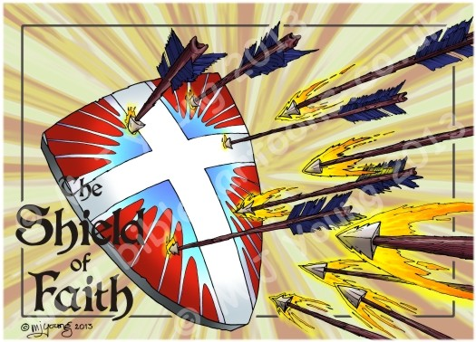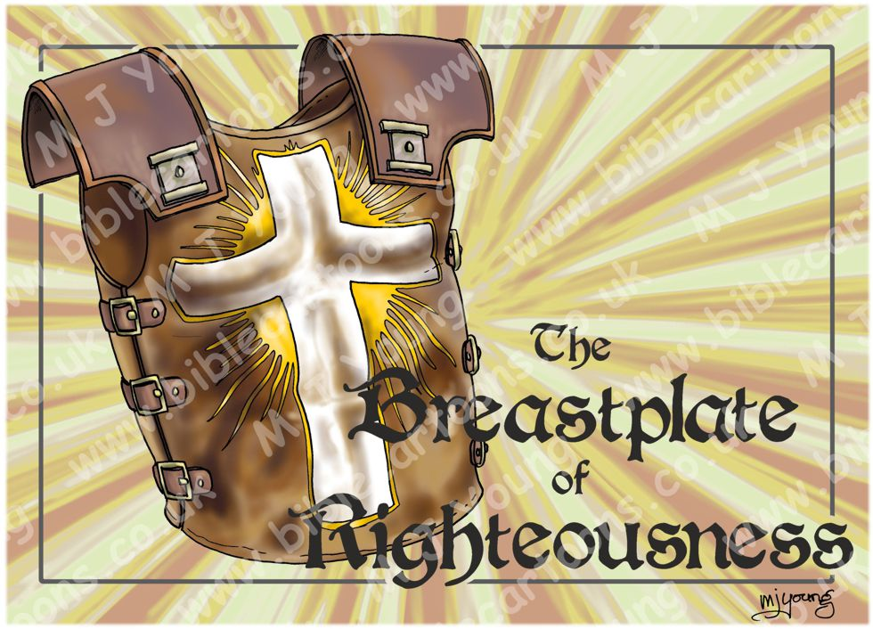

If you have a righteous heart; you will please God. The **Breastplate of Righteousness** will help you avoid sin or ask for forgiveness so you can be “right” before God.

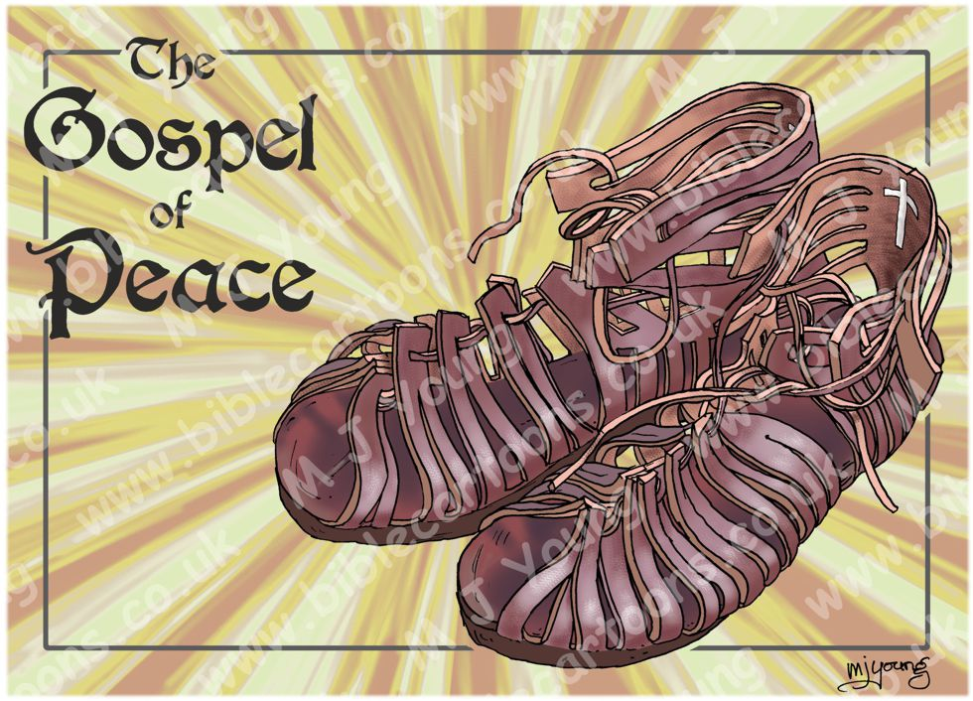

The shoes of Peace prepare you to face the enemy with firm-footed stability and help you be ready to tell others about Jesus and the **Gospel of Peace**.

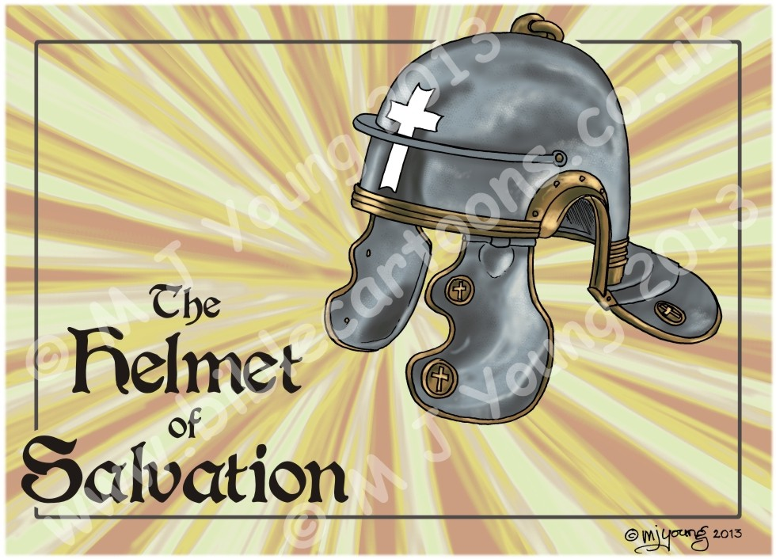

The **Helmet of Salvation** helps your mind stay focused on Jesus. If you believe in Jesus and confess your sins you have the gift of salvation because Jesus died for you.

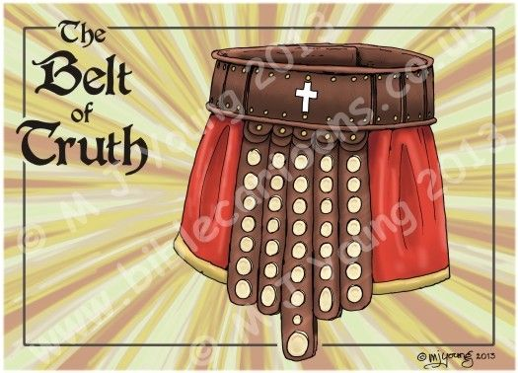

The **Belt of Truth** guides you on the right path. As you learn God’s truth you can avoid sin and stand up for what is right. If you know God’s truth, you can make wise choices.

Your only weapon is the **Sword of the Spirit** which is the Word of God or the Bible. All the other pieces are Armor, but the Scripture is a weapon you can use to fight the enemy.

